Analyse and design a MySQL C# based game. Prototype TSQL procedures for game functions. Revise and refactor the codebase and GUIs. Implement multiuser concurrency.

DAT602 Project

MySQL Game

13/11/2024

Jayden Houghton – 13524050

Contents

Design (Milestone 1) 2

Game Description 2

Graphical Design 4

Logical ERD 11

CRUD Table 11

DDL SQL 14

Prototype Application 19

SQL Procedures (Milestone 2) 23

Design Notes 23

Login Procedure 24

Registration Procedure 28

Layout Procedure 30

Generate Map (Place Items) Procedure 34

Player Movement Procedure 38

Update Score Procedure 42

Interact (Pickup) Procedure 44

NPC Movement Procedure 48

Stop Game Procedure 52

New Player Procedure 55

Update Player Procedure 57

Delete Player Procedure 60

Multiuser Concurrency (Milestone 3) 63

References 63

# Design (Milestone 1)

## Game Description

**Concept**

Survivor Island is a 2D point-and-click style game. Two or more players can verse each other, racing to collect items and stay alive the longest. Plays can click on tiles to move around the 2D tile map. The island is covered in an assortment of items, including food to heal health, treasure to increase the score. Fighting animals will award score points but reduce health.

**Items**

Once on a tile with an item, players can click again on the tile to interact with the item. Food items will be added to the players inventory and treasure items will be instantly converted to score. Items are spawned at random empty tiles throughout the game.

Picked up items are added to the inventory and stacked in designated slots, while treasure is automatically converted to score. Use buttons will use the related item and apply its effect.

|  |  |  |
| --- | --- | --- |
| Item | Type | Effect |
| Fruit | Food | Health +20 |
| Meat | Food | Health +50 |
| Coin | Treasure | Score +1 |
| Gem | Treasure | Score +5 |

**Hunting**

NPC animals will spawn at random tiles around the map. Moving to a tile with a creature and clicking the tile again will trigger the fight calculation. Successfully hunting an animal will award score points. Animals will wander randomly around the map with a simple algorithm.

|  |  |
| --- | --- |
| Animal | Effect |
| Spider | Health -10, Score +5 |
| Snake | Health -30, Score +10 |
| Boar | Health -80, Score +20 |

**Scoring and Winning**

Score points are gained through picking up treasure and hunting animals. The game ends when there are no items and animals left (as there is no way to gain score). The player with the highest score wins!

**Accounts**

Players can login to their personal account. If the account does not exist, it will automatically be created. Accounts can be banned by admins and will be locked if a user fails too many login attempts. Accounts store basic information about the player and all of their characters. Accounts can be deleted by the player.

**Admins**

Some accounts will have admin abilities. This includes killing running games, adding new players, updating existing player’s data, deleting player accounts and banning an account.

**Map**

The map is composed of 2d tiles, that may have other items, animals or obstacles placed on top. The map and item placement will be randomly generated. Player’s move by clicking on an adjacent tile (no diagonal). Some tiles will be filled with obstacles (e.g. rocks) which the player cannot move to.

**Lobby and Games**

Once signed in, each player will be able to see a list of all other online players and their highest score. Player’s can click on another player to send a game request. If the other player accepts, a new game is started.

**Chat**

Each game has its own text chat where players can message each other.

## Graphical Design

**Login and Register**

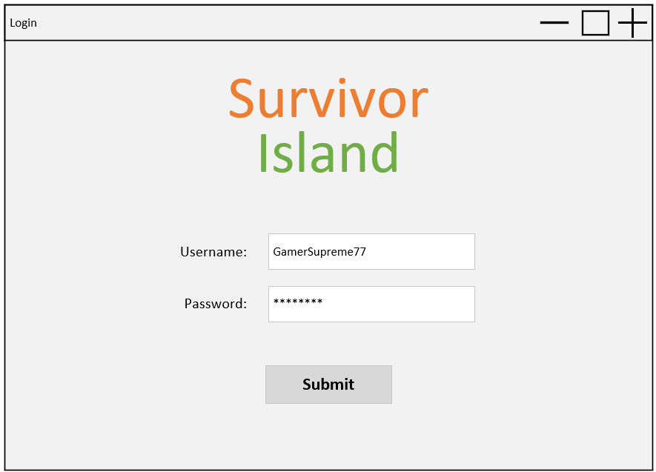

3

2

1

*The user loads up the game, entering their username and password, then clicking the submit button to login. New players enter the username and password they want to set for their account.*

1. Username is used for login and also how the player is named in the game.
2. Password is hidden for security.
3. Submit attempts to login the user.
   1. If the username is found but password is incorrect, display login failed popup (below).
   2. If username not found, display register popup (below). If clicked yes, go to lobby and create new account in database.
   3. If account is locked, display locked account. Account will be locked if 5 failed login attempts are made.

*The user entered incorrect login details.*

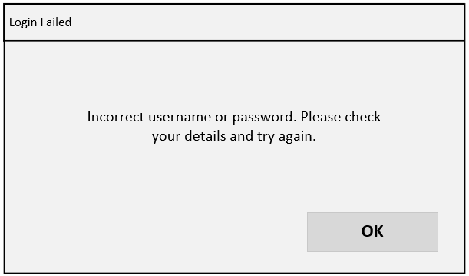

*The username does not exist, so a new user is being made.*

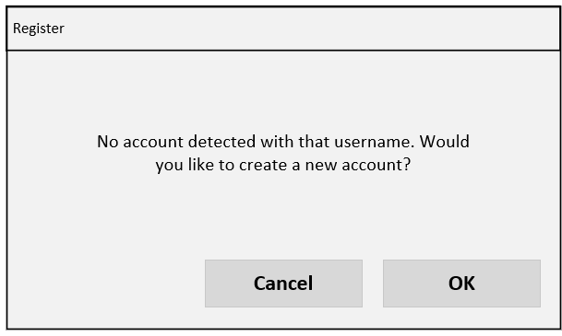

*The user has inputted incorrect passwords too many times and has been locked out.*

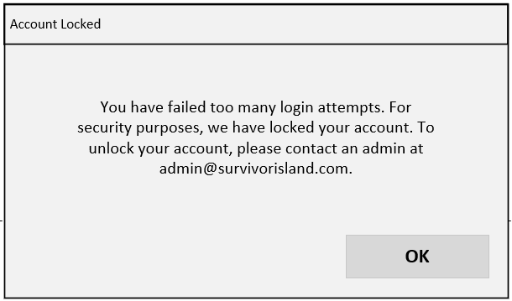

**Lobby**

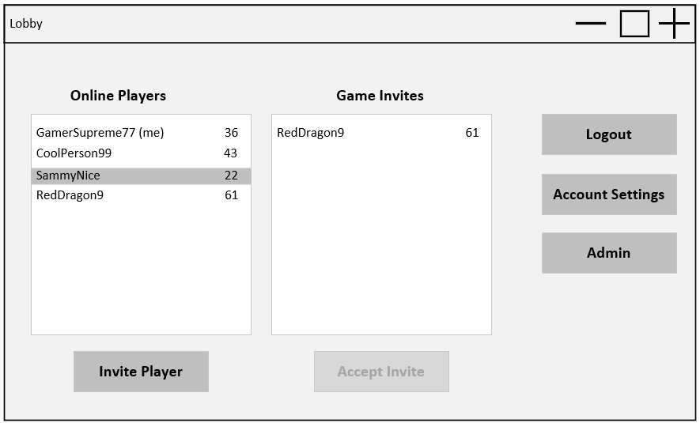

7

6

5

4

3

2

1

*The user has successfully logged on. Selecting the online player SammyNice from the Online Players list, the user clicks invite player. SammyNice will receive a game invite from the user, which will be listed user Game Invites. If SammyNice selects the game invite and clicks Accept Invite, the game will begin.*

*After playing a game, the user clicks Account Settings to update their password.*

*After updating their password and returning to the lobby. The user clicks Logout to log out and return to the login screen.*

1. Shows all currently online players with their highest score.
2. Select a player in the list then click invite player to send a game invite.
3. Shows all players that have invited you to a game.
4. Select an invite and click accept invite to begin a game.
5. Logs out and opens login page.
6. Opens account settings page with player data.
7. Only visible for accounts with admin. Opens admin window.

**Account Settings**

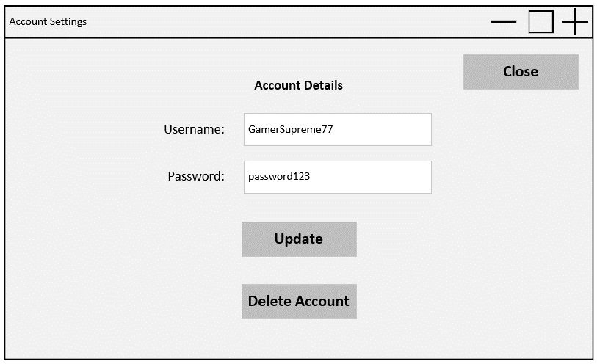

2

1

*The user wants to update their password. They replace the current password with their new password, click update, then click the close button to close the window and return to lobby.*

1. Updates the player info in the database.
2. Opens delete account confirmation popup. Accepting opens the login page and removes account from database.

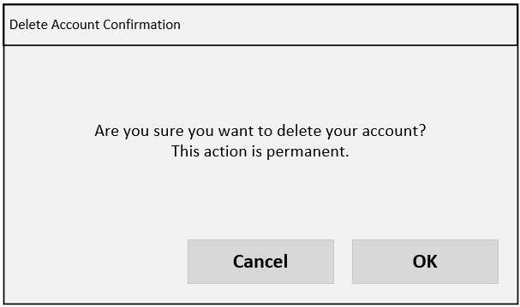

*The user clicks delete account in the account settings window then clicks OK to delete their account.*

**Admin Overview**

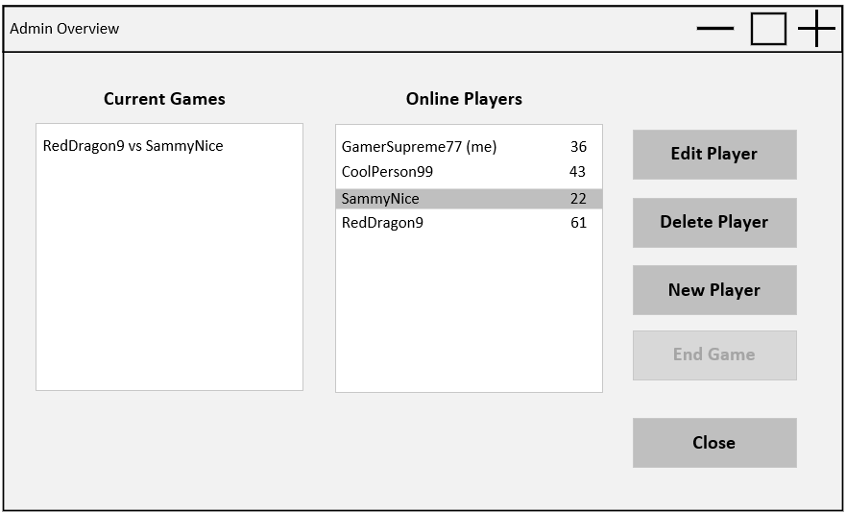

3

4

5

6

2

1

*After clicking Admin in the lobby, an admin user can view all online players, active games, and admin controls. Clicking edit player opens the account settings page (variant of above account settings page), where the admin user changes their password, unlocks their account, and saves changes, allowing a locked-out player to log in.*

1. Shows all current active games.
2. Shows all online players.
3. Selecting an online player and clicking edit player, opens up the account settings page (variant of above) with that player’s data.
4. Selecting a player and clicking delete player will open up the delete account confirmation popup. Clicking OK will delete this account.
5. Clicking new player will open up the make account screen (below). Clicking make account will create the account in the database.
6. Selecting an active game and clicking end game will stop and delete the game.

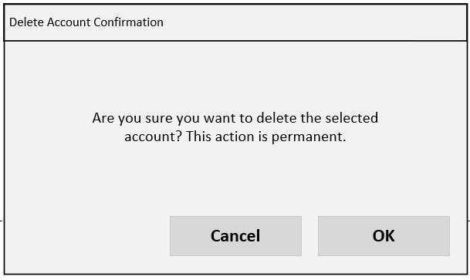

*Admin user selects an online account, clicks delete account, then clicks OK to delete user.*

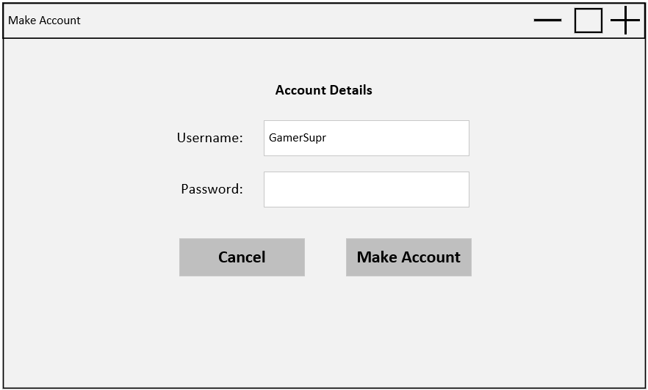

*Admin clicks New Player from the admin page, enters username and password, then clicks Make Account to make the new user.*

**Game**

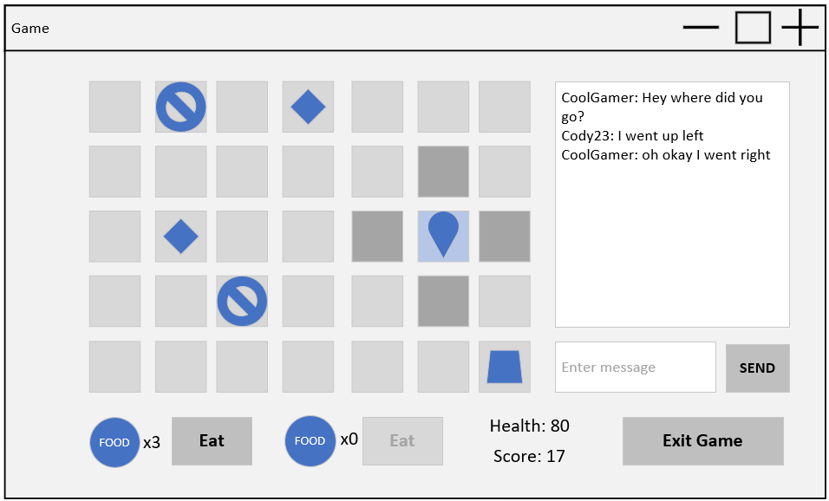

9

3

8

7

6

5

4

2

d

c

b

a

*The player clicks on adjacent tiles to move their character until they are on top of an item (e.g. gem). The player clicks the time again to pick up the item, which processes the items effects, in this case increasing score and setting the time to blank. The player moves again by clicking adjacent tiles until they are on the same time as an animal (e.g. snake). The animal moves to adjacent tiles at random intervals. Once on the same tile, clicking the tile again ‘hunts’ the snake, reducing the user’s health, increasing score and changing to a blank tile. The player clicks on adjacent tiles again to move across the board to a food item (e.g. fruit). Once on the time, the player clicks again to pick up the item, which is added to their inventory (shown bottom left of the screen). The player clicks the eat button nest to the related food item, increasing their health and reducing the quantity of that item in the inventory by one. The player then clicks on the chat message box, types out a message and clicks Send. This displays the message in the chat log, which all players in the game can see.*

Items are randomly placed when the board is loaded. The player starts on the home tile (1,1).

1. Items are randomly placed when the board is loaded. Mock-up key:
   1. Player
   2. Obstacle
   3. Item
   4. Animal
2. Exits the game back to lobby
3. Score is increased when collecting treasure or hunting. Highest score at the end of the game wins.
4. If at least one food item of the respective type is in the inventory, clicking eat will use it and apply its affects (only two food types).
5. Clicking an adjacent valid tile will move the player to that position. Valid means no player (however items or animals are excluded).
6. Animal
   1. When standing on a title with an animal or item, clicking the tile again will hunt the animal or pickup the item, applying the related effects to health, score and inventory.
   2. Animals will randomly move to adjacent times at intervals.
7. Recent chats by players in the game are displayed here
8. Any typed message will be displayed in the chat.
9. Displays health which is affected by hunting animals (reduces) or eating food (increases).

## Logical ERD

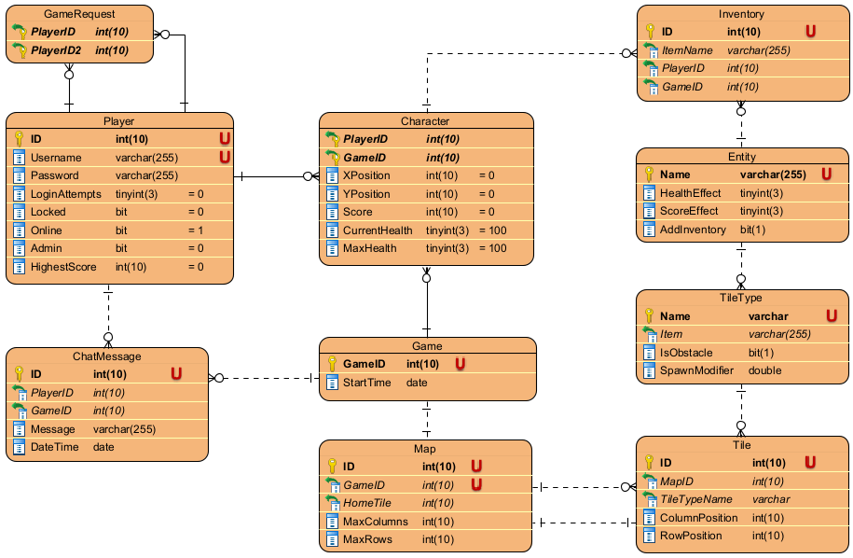

## CRUD Table

Key: C = Create, R = Read, U = Update, D = Delete

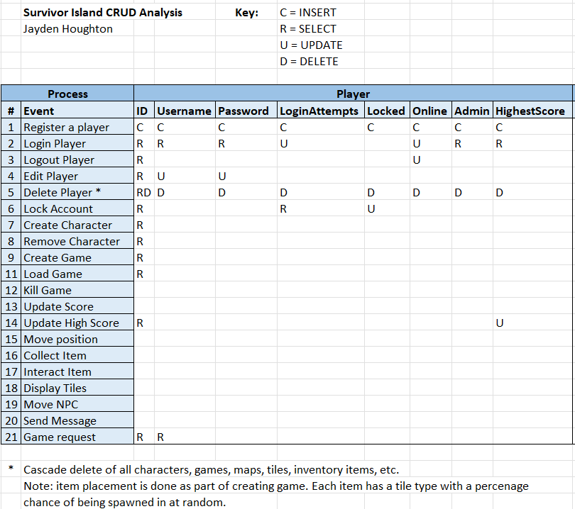

* Cascade delete of all characters, games, maps, tiles, inventory items, etc.

Hote: item placement is done as part of creating a game. Each item has a related tile type, which has a percentage of being spawned at random when generating the map.

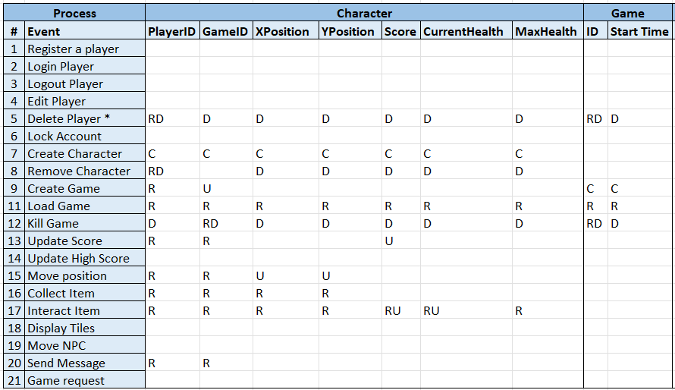

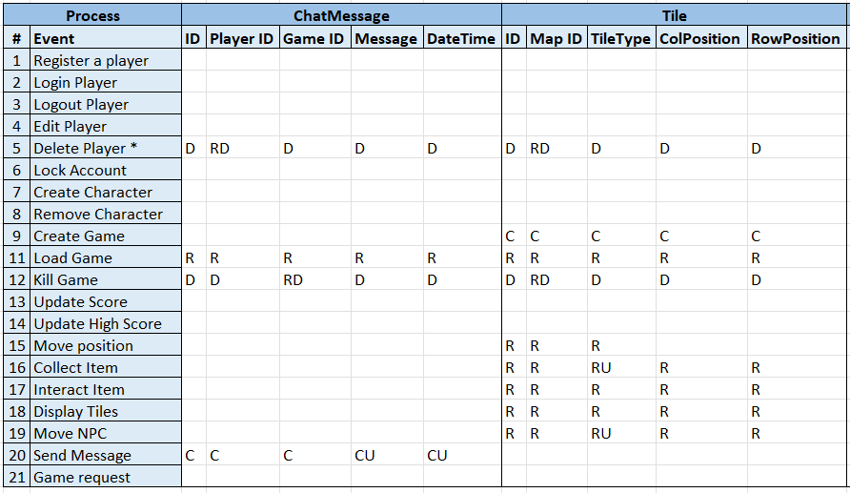

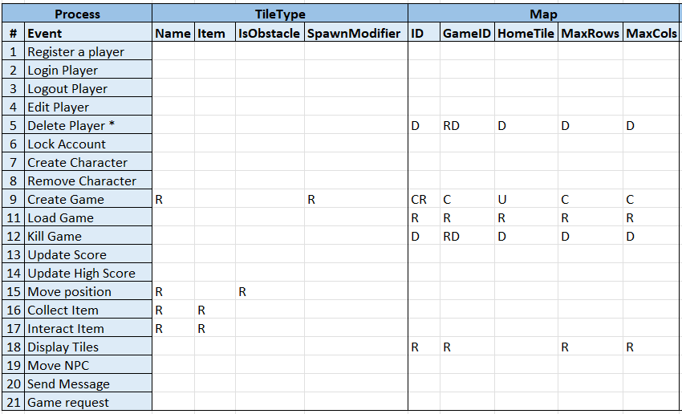

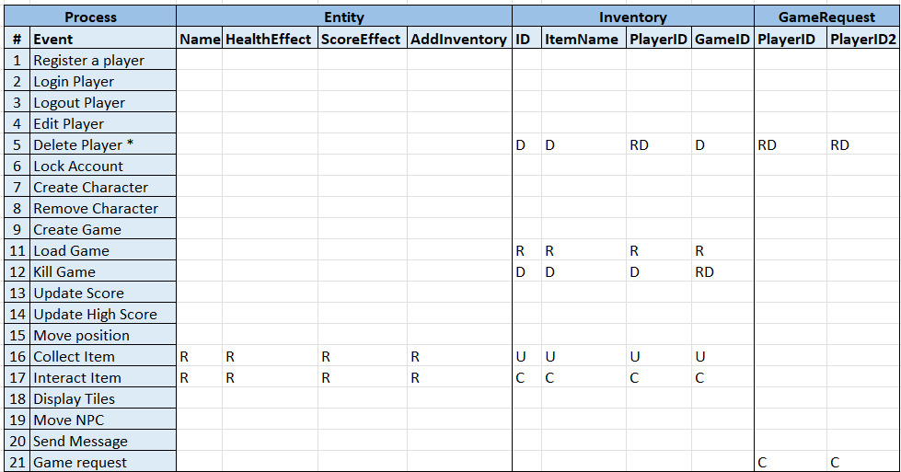

## DDL SQL

**Start.sql**

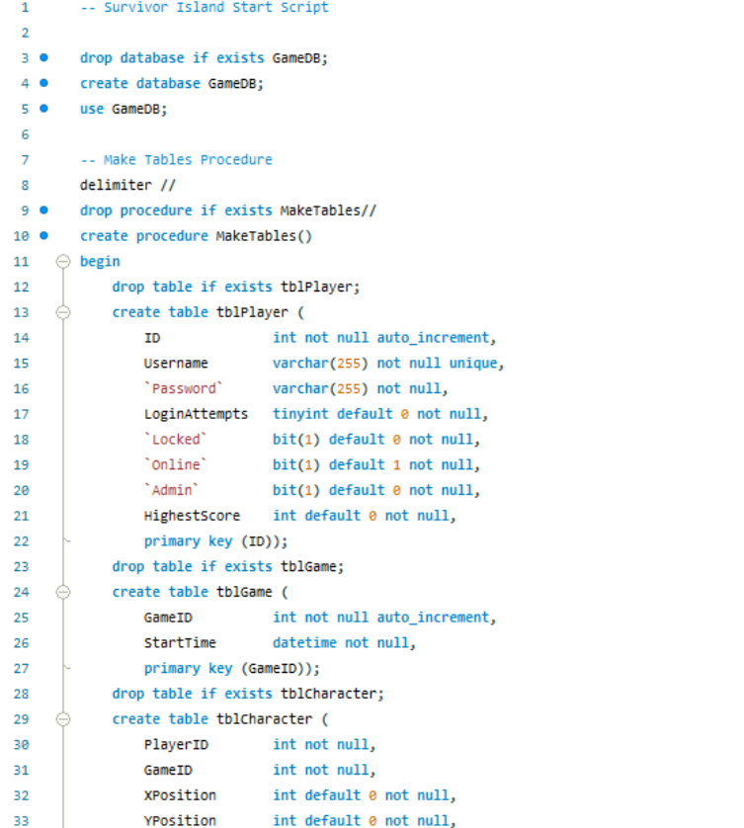

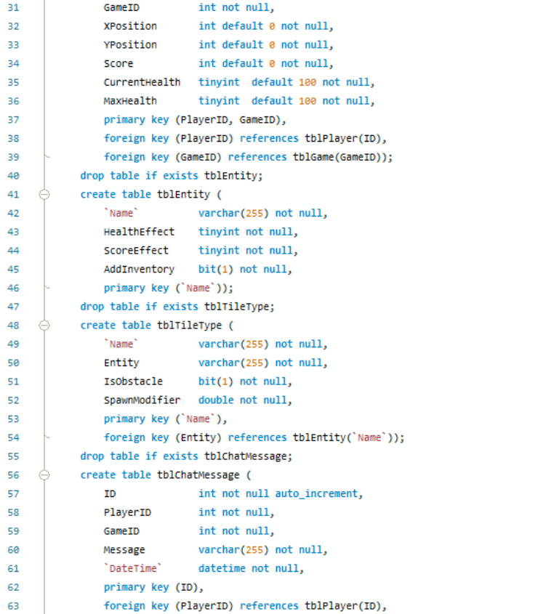



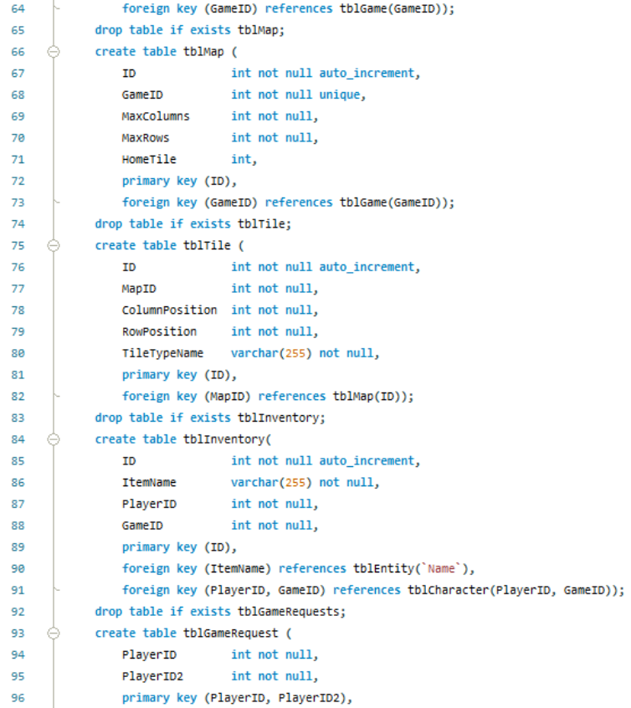

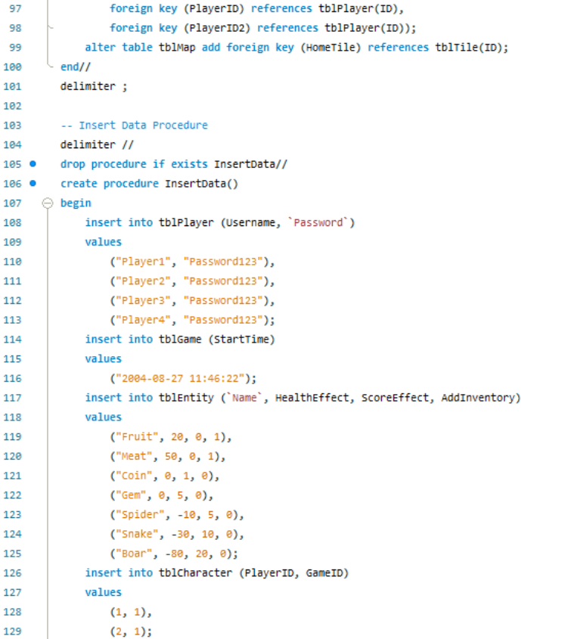

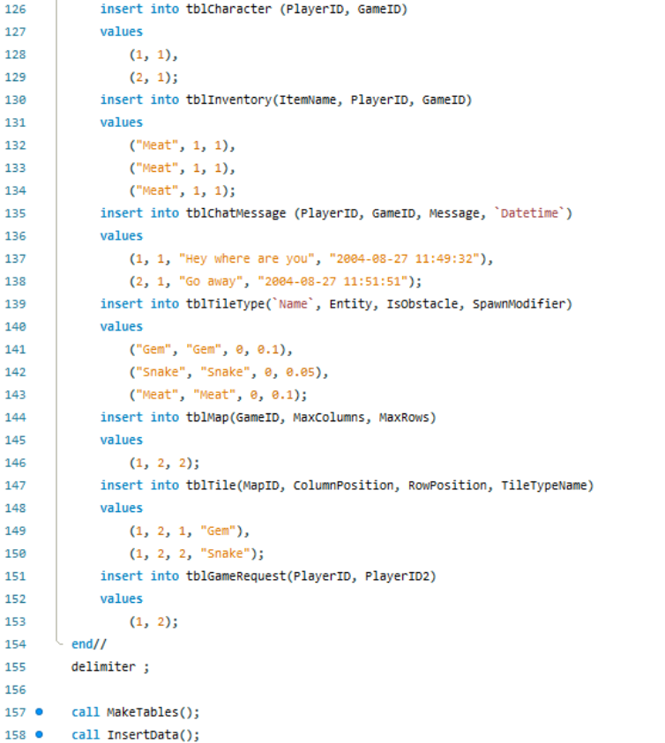



**Test_procedures.sql**

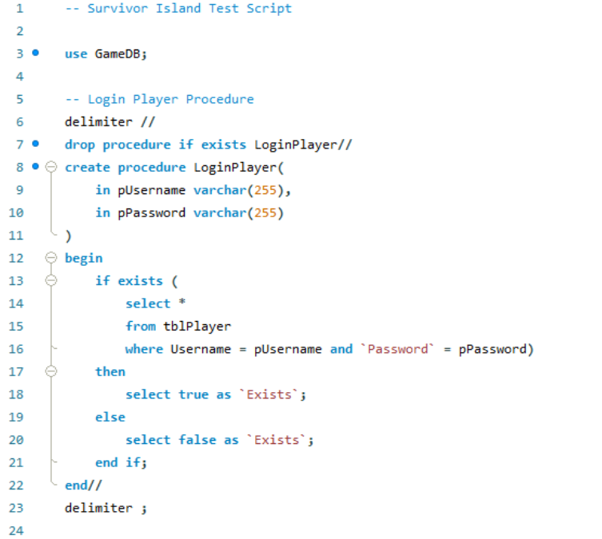

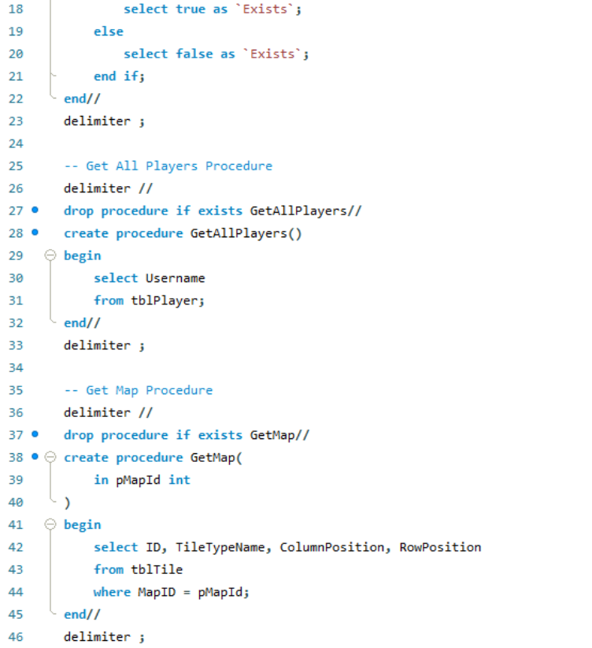

## Prototype Application

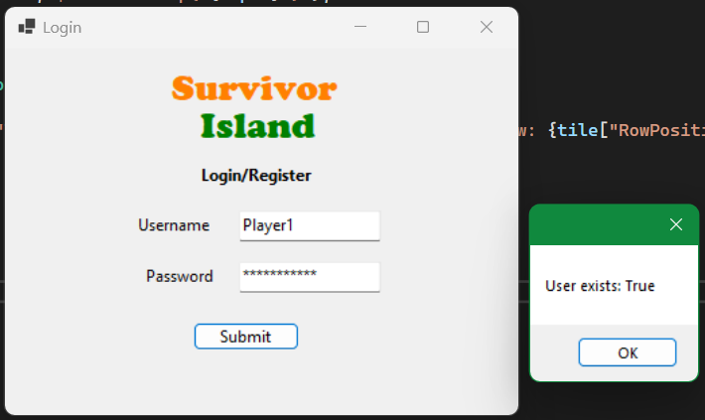

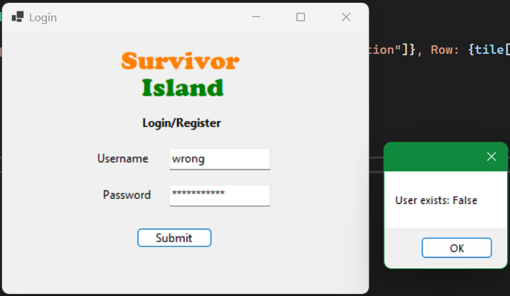

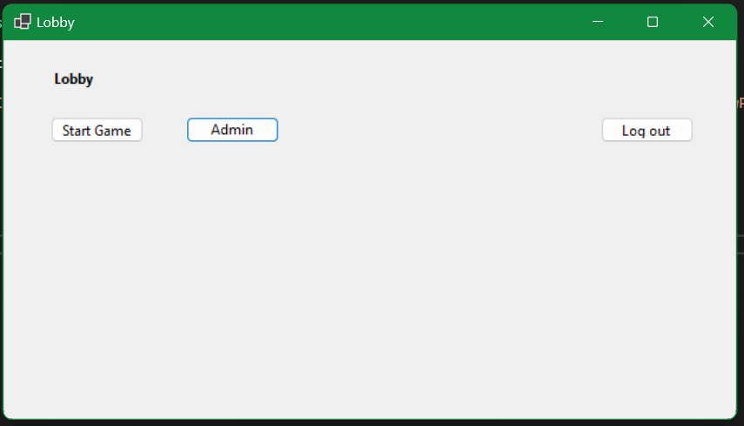

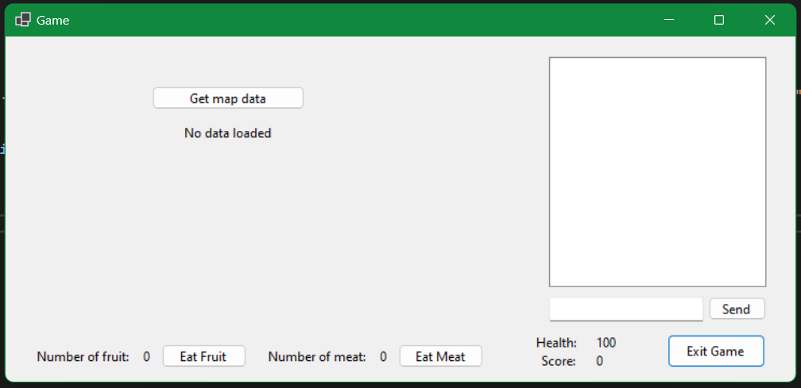

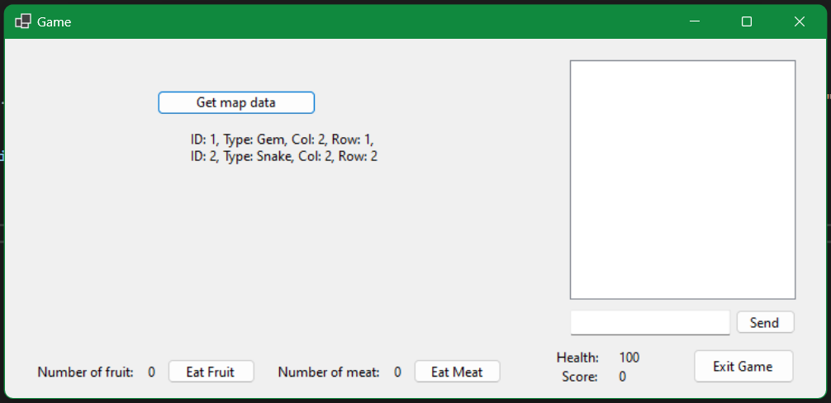

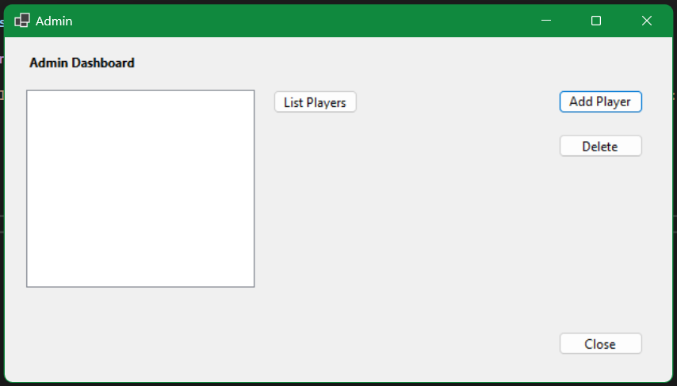

Note: input is the list box where admins can select players or games and click buttons to perform actions.

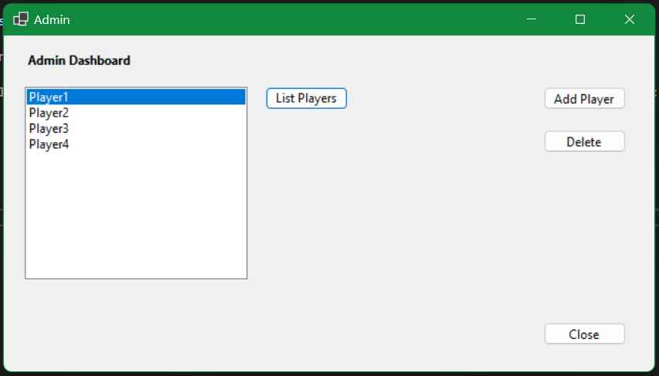

# SQL Procedures (Milestone 2)

## Design Notes

**Files**

* Please read the readme.md in the c# project for instructions on how to run the program.
* Please read the readme.md in the /db subfolder for instructions on the MySQL files.

Note: added ID to tblCharacter instead of using GameID and PlayerID as a composite key. This became quite complex to use in many queries and data rows, as CharacterID is used frequently, so I decided it was better to add a designated key.

**Draft Logic Flowchart**

For C# logic, procedure calling, procedure logic and database actions.

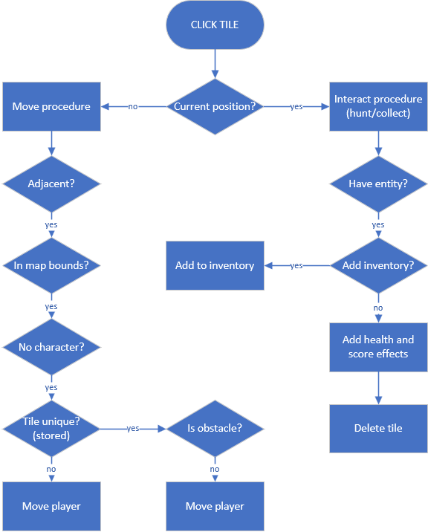

## Login Procedure

### MySQL Procedure

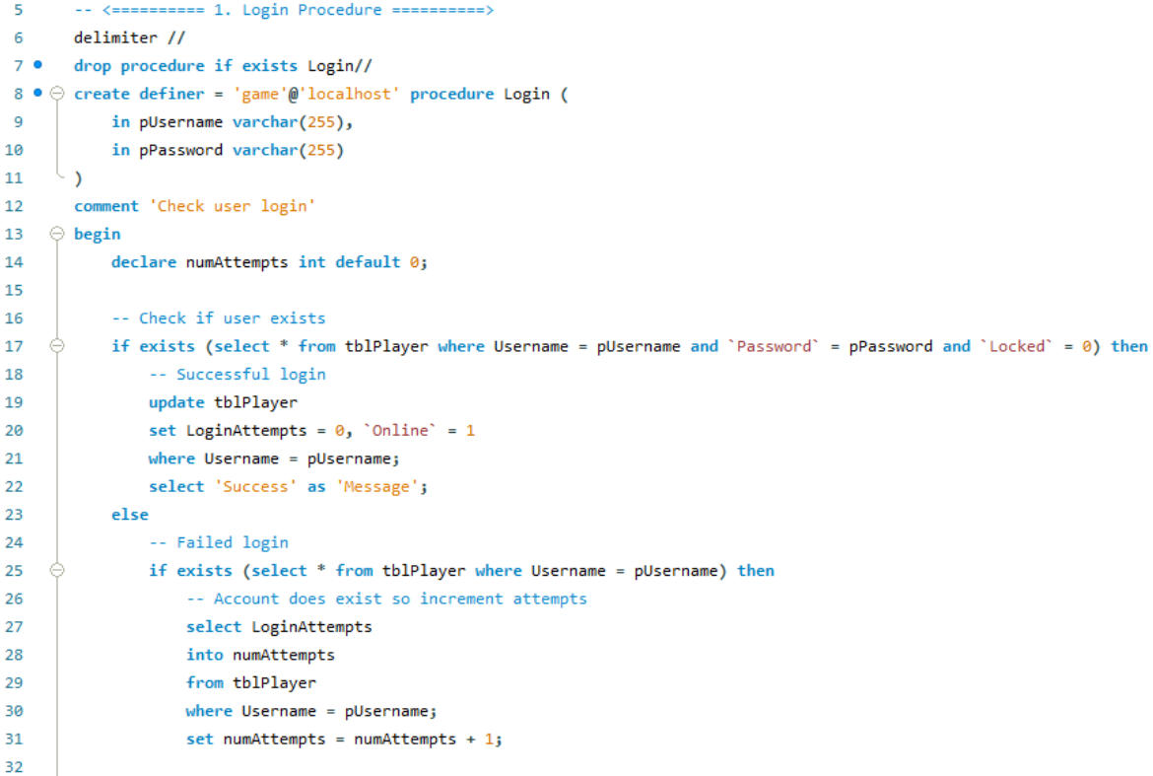

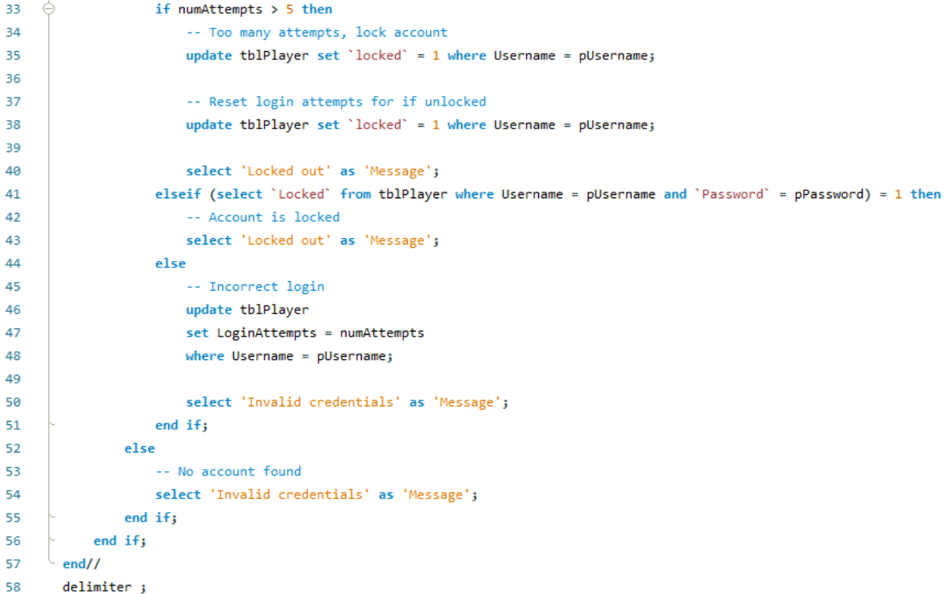

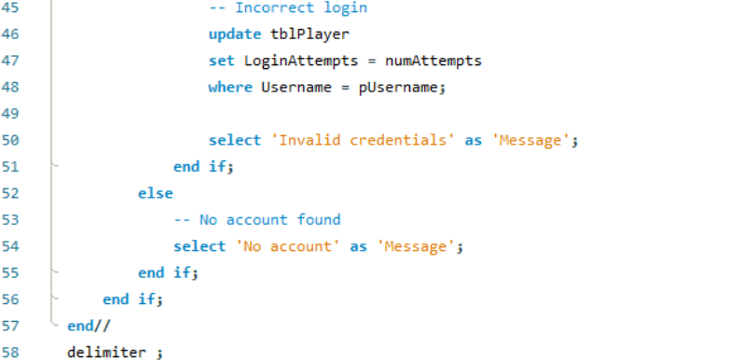

**Test Calls and Checks**

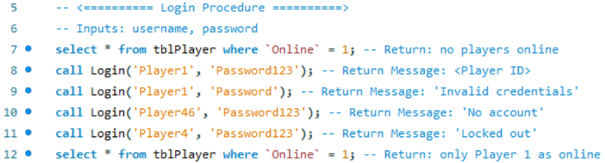

**Results**

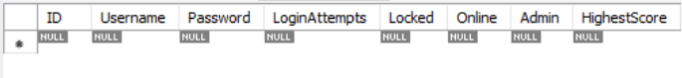

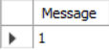 Player login (Player ID = 1)

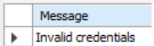 Invalid username or password

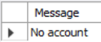 No matching username

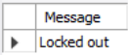 Too many failed login attempts

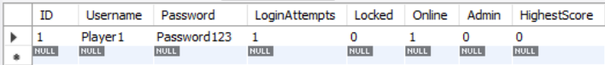

### C# Test

**DAO Method**

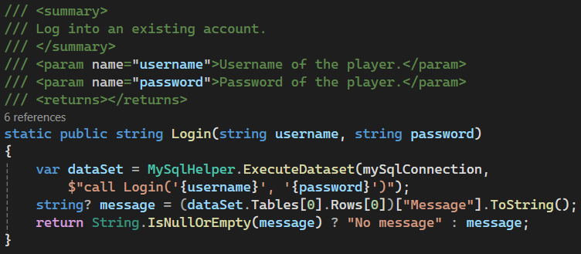

**Test Calls**

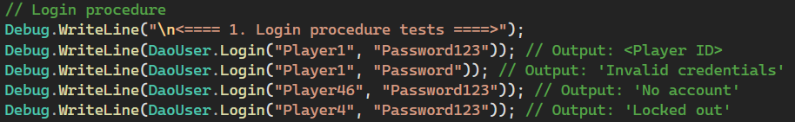

**Log Outputs**

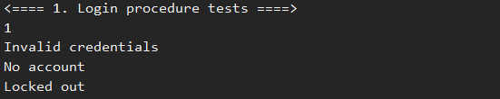

### GUI Implementation

When the login button is pressed, the inputs are collected and sent to the User DAO. If the login method returns a player ID, the lobby is loaded, else a switch statement handles the other possibilities.

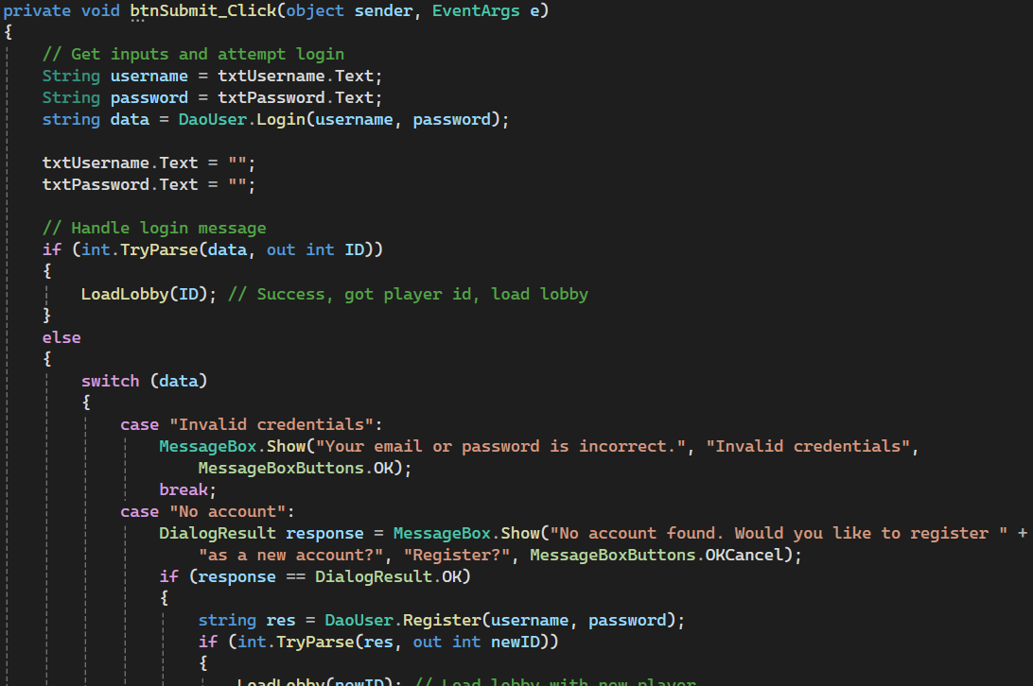

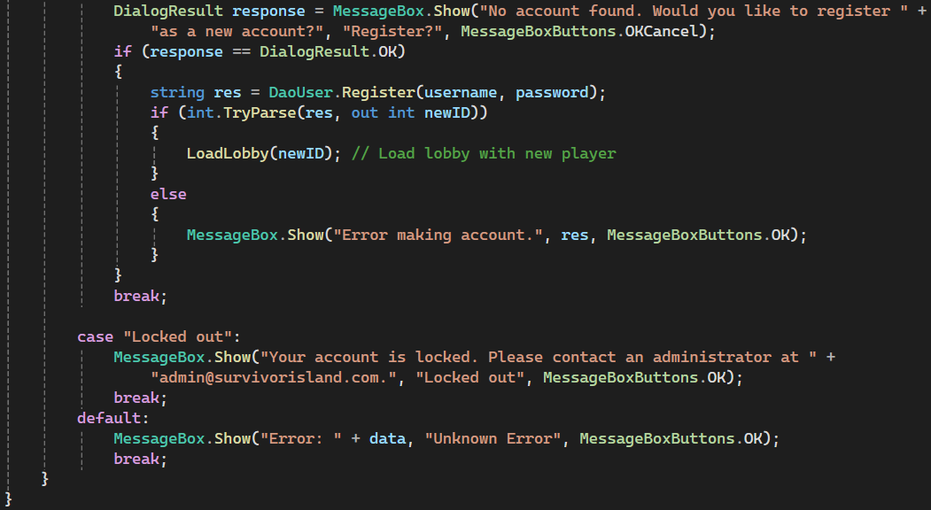



Successful login opens the lobby screen.

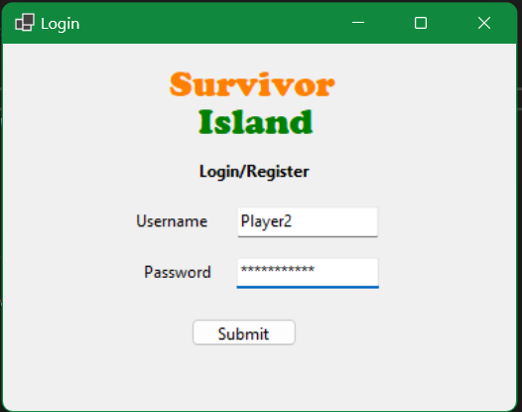 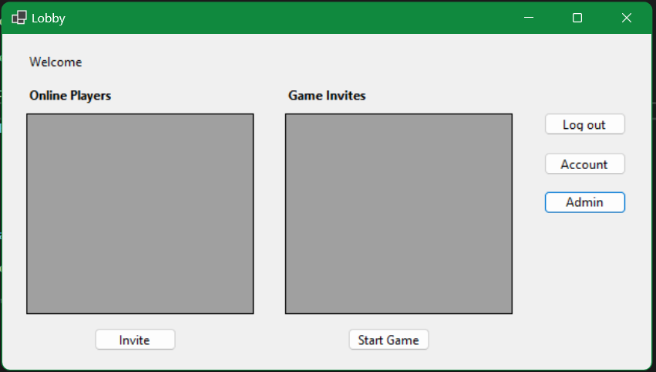

Incorrect password opens message pop up.

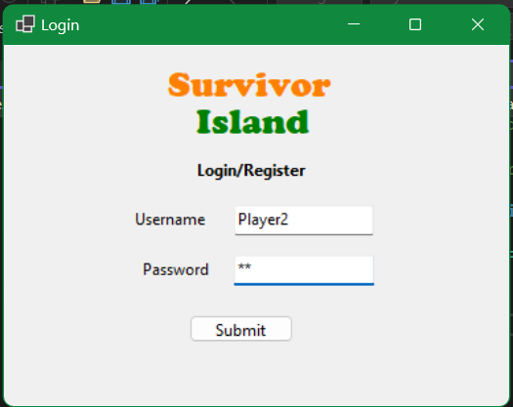 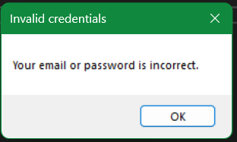

Attempting to log into a locked account gives locked out message.

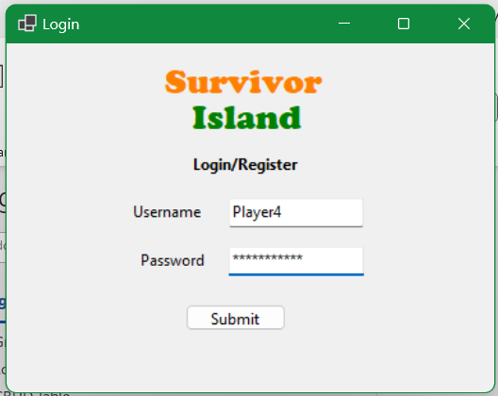 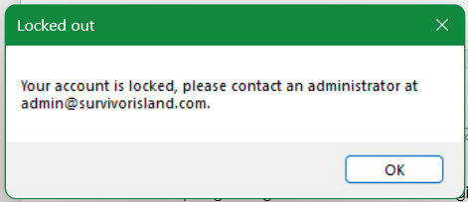

## Registration Procedure

### MySQL Procedure

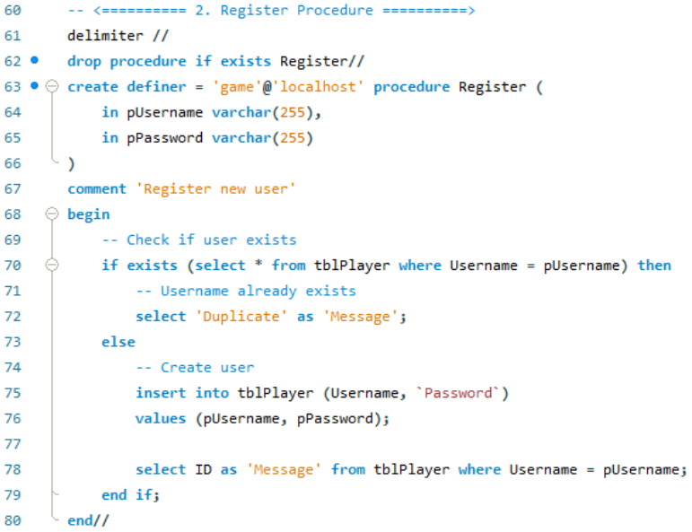

**Test Calls and Checks**

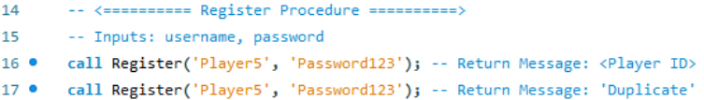

**Results**

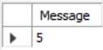 Register new user, returns player id

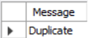 Using duplicate email

### C# Test

**DAO Methods**

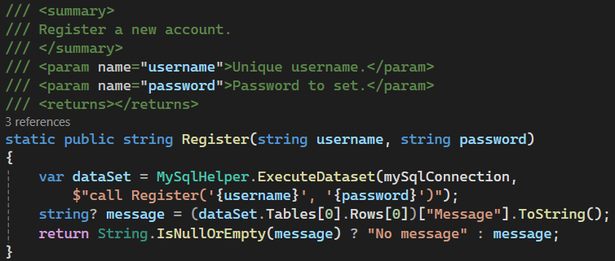

**Test Calls**

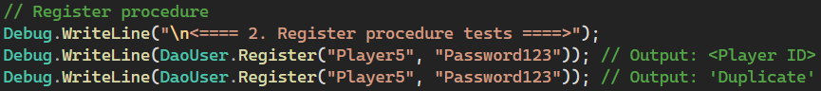

**Log Outputs**

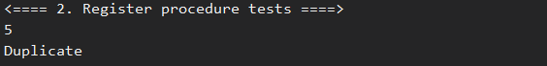

### GUI Implementation

As a part of the login process, if the login method comes back with “No account”, the user will be prompted if they want to make a new account. If they confirm, the account will be made, and the lobby will be loaded.

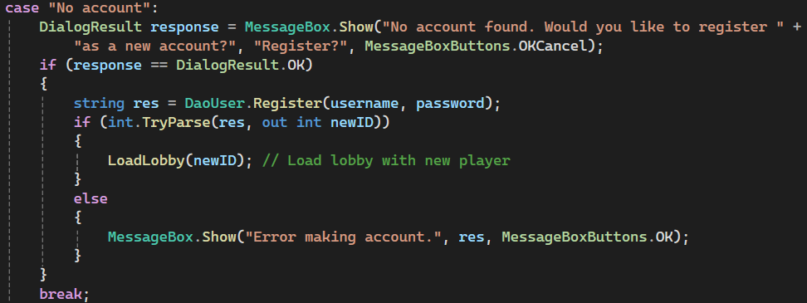

New unique username prompts registration, then opens lobby if accepted.

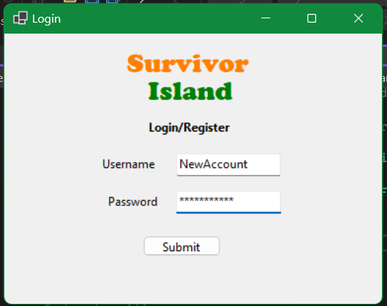 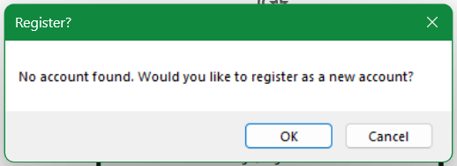

## Layout Procedure

### MySQL Procedure

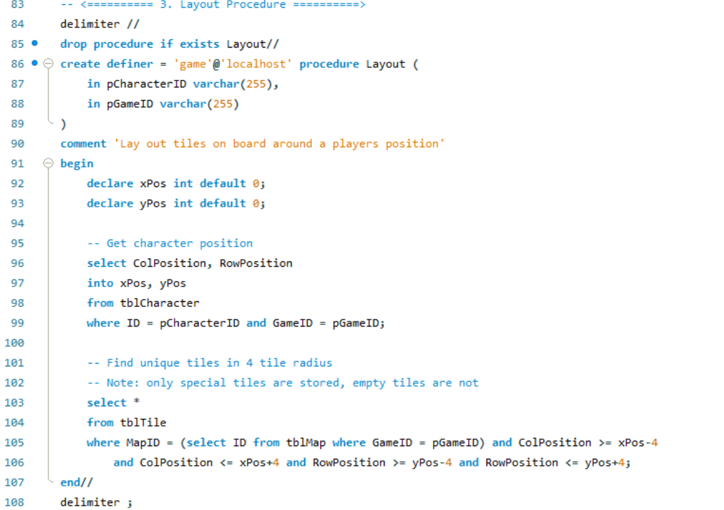

**Test Calls and Checks**

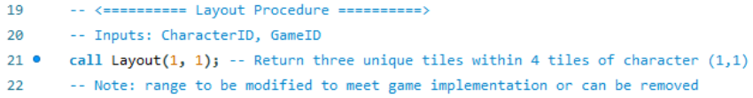

**Results**

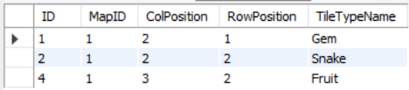

### C# Test

**DAO Method**

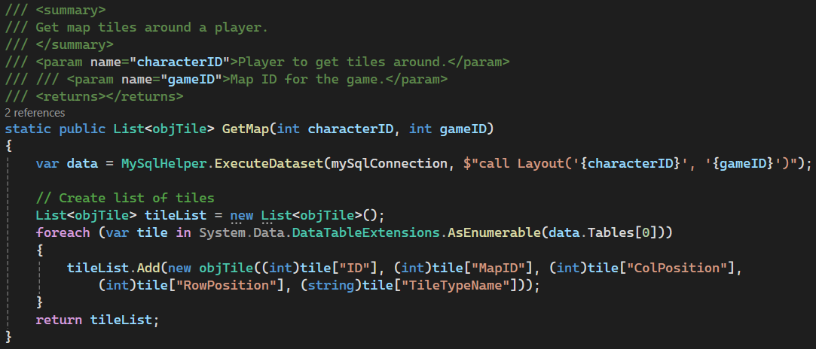

**Test Calls**

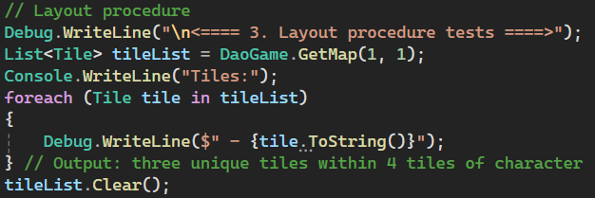

**Log Outputs**

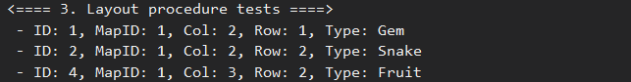

### GUI Implementation

When the start game button is pressed in the lobby, the game will check if there is an existing game with both player ids. If yes, the game will be loaded with this data. If not, a game will be generated, including the map, tiles and characters before loading the game screen.

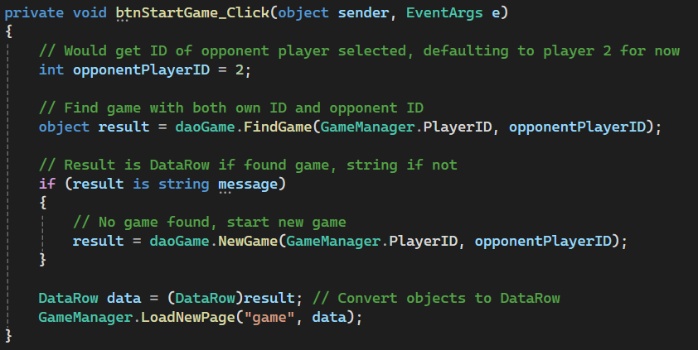

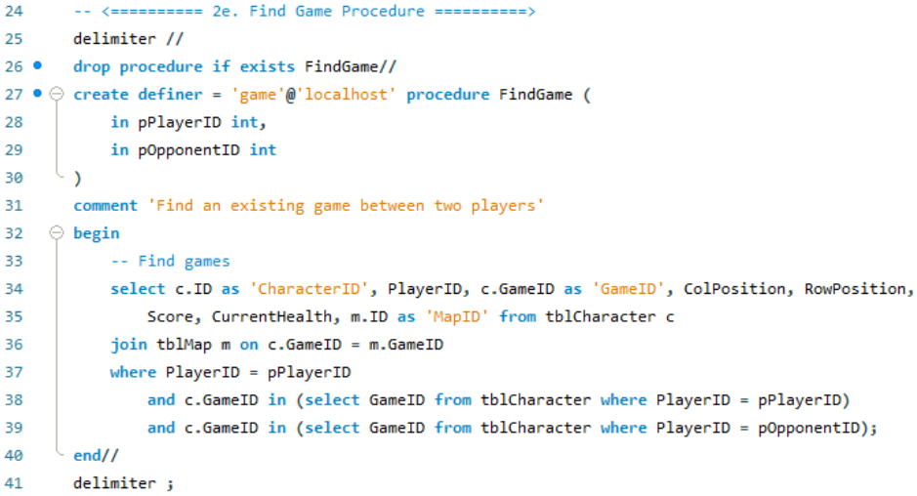

When the game screen is loaded, data is pulled from the database on the current player position and the surrounding map tiles. Every time a button is pressed, the update method is called to update the board.

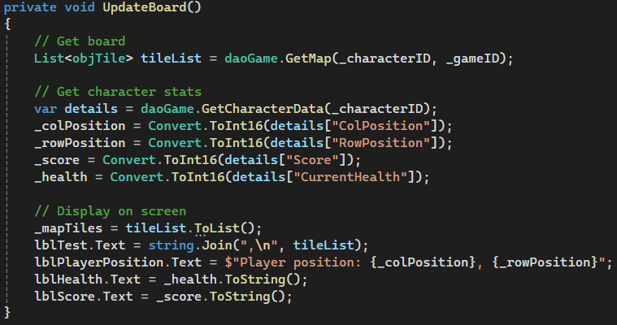

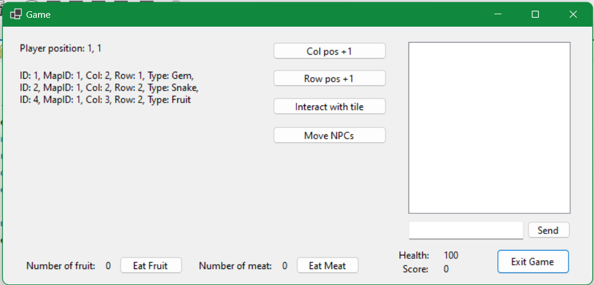

## Generate Map (Place Items) Procedure

### MySQL Procedure

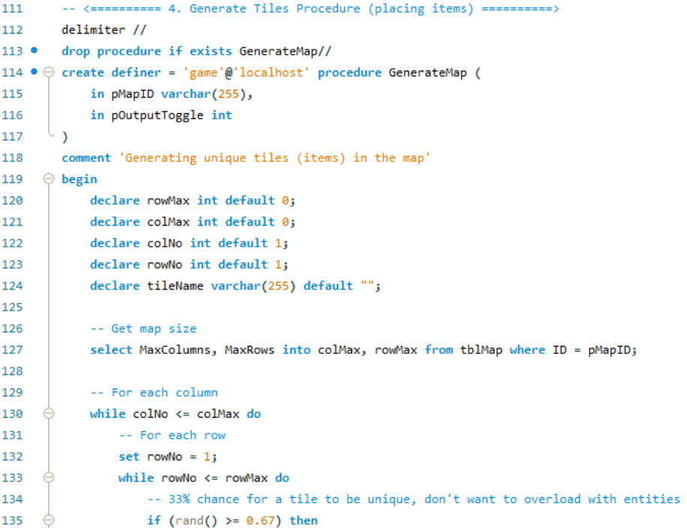

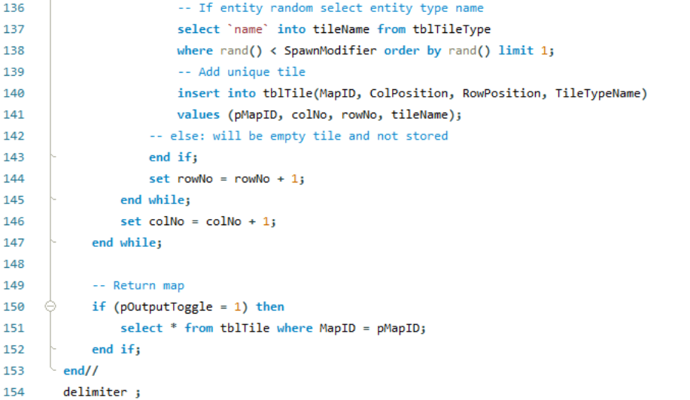



**Test Calls and Checks**

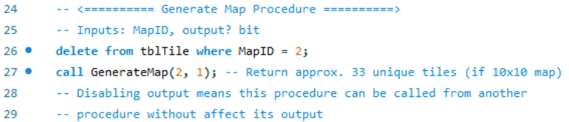

**Results**

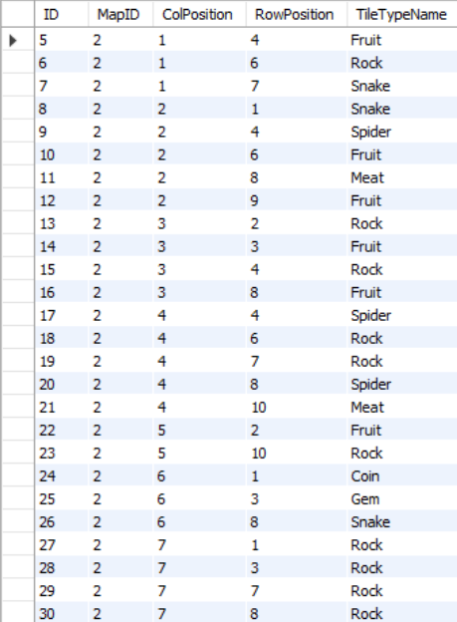 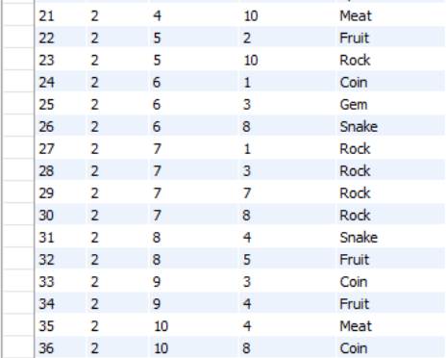

### C# Test

**DAO Method**

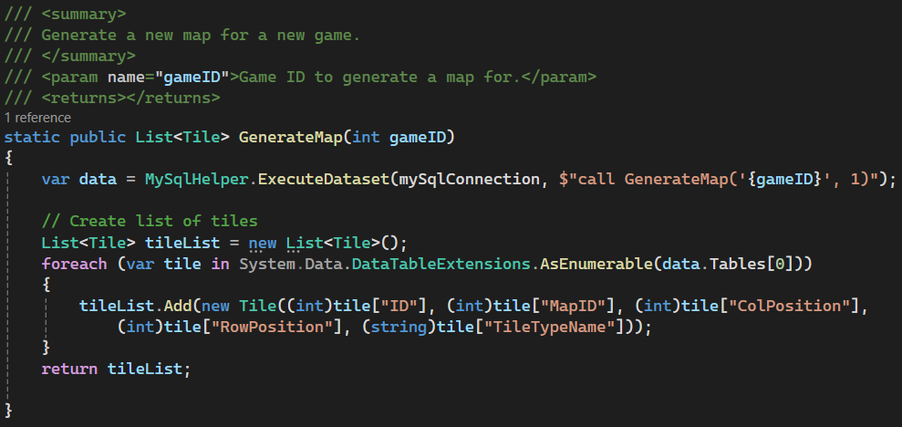

**Test Calls**

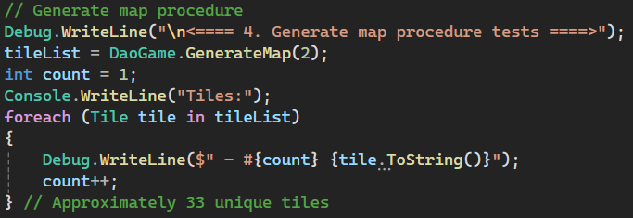

**Log Outputs** (shortened)

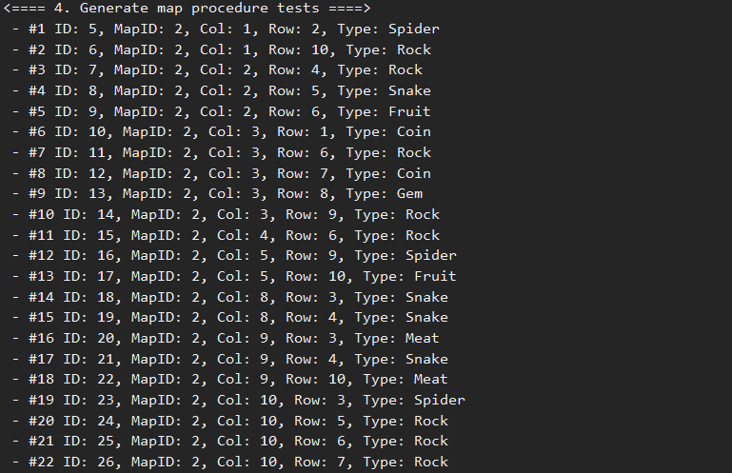

### GUI Implementation

If a game is not found between the two player ids, a new game will be made. This includes generating a new map, all of the map tiles, and new characters.



As a part of the start game procedure, it calls the generate map procedure (line 74), generating the tiles for the newly map game and map ids.

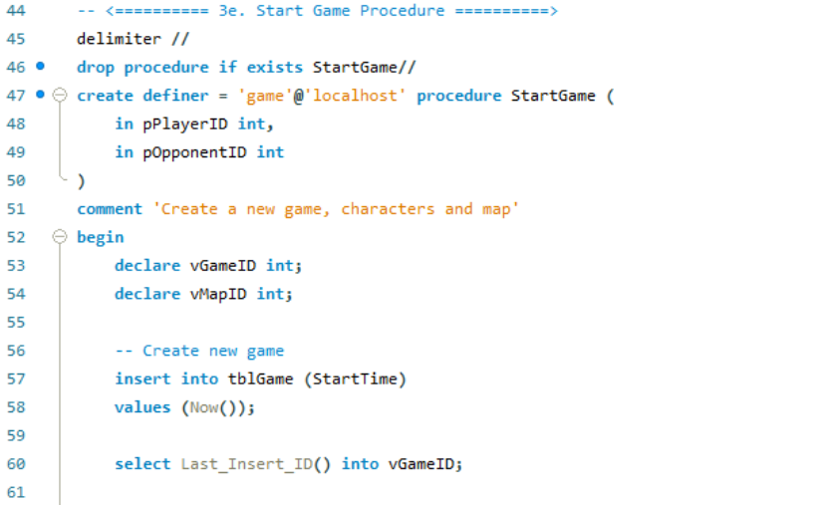

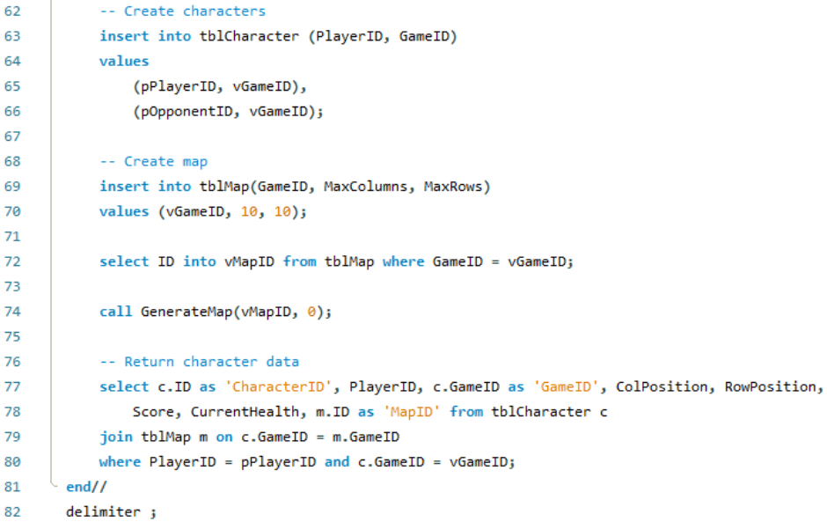

Player 3 (U: “Player3”, P: “Password123”) is not in a game, so clicking start game on their account will generate a new game.

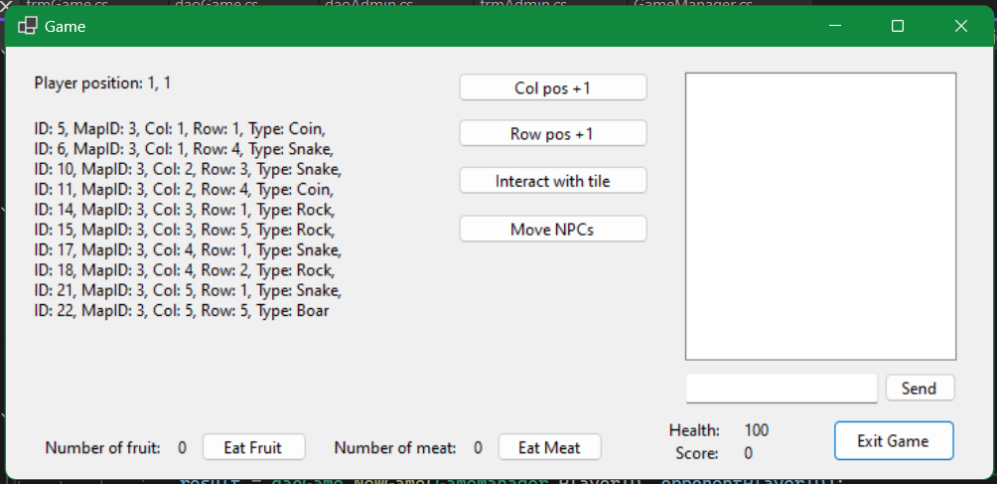

## Player Movement Procedure

### MySQL Procedure

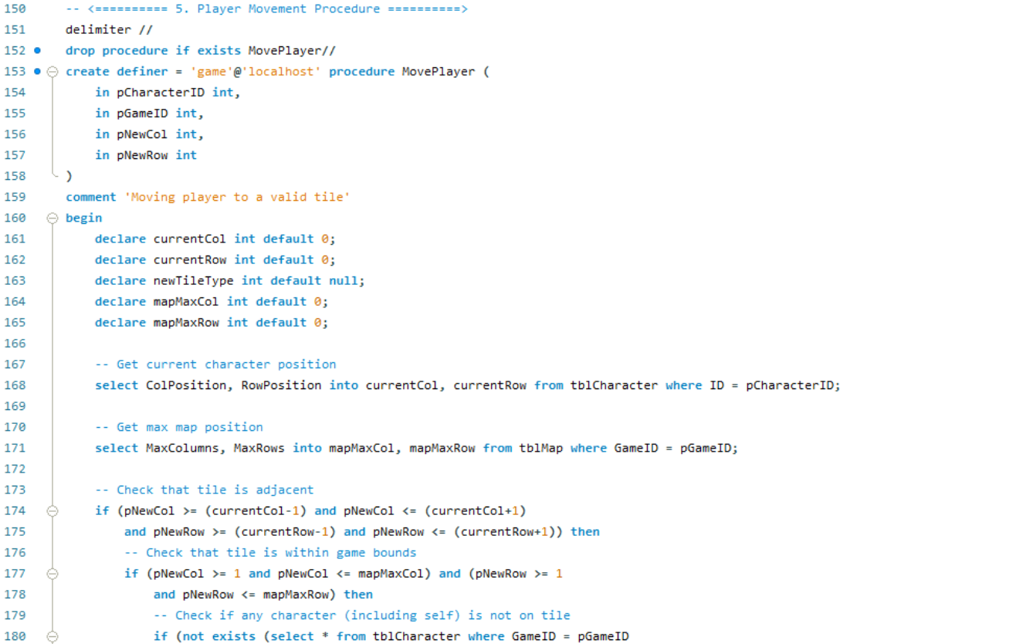

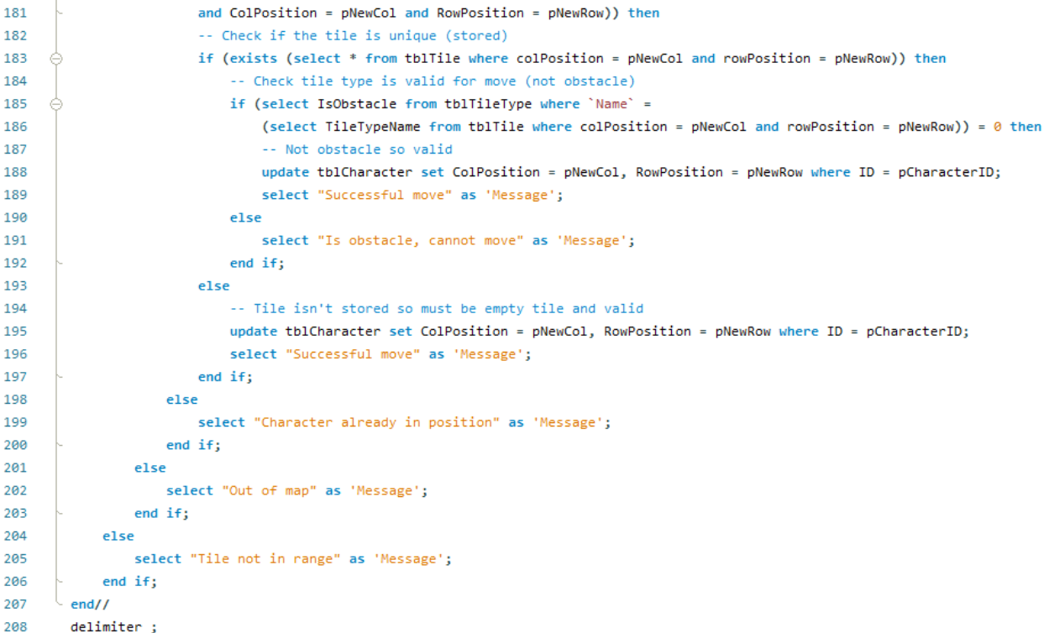

**Test Calls and Checks**

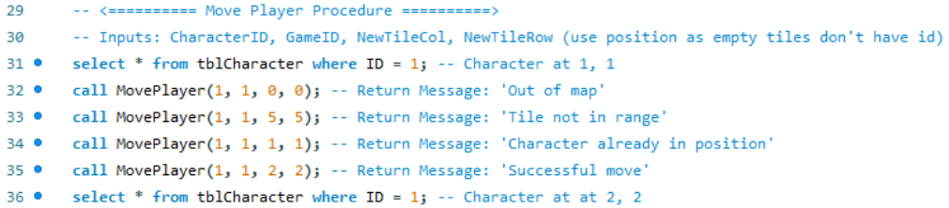

**Results**



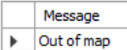 Test invalid tile

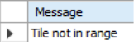 Test invalid tile

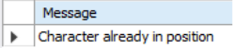 Test invalid tile

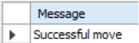 test valid tile



### C# Test

**DAO Method**

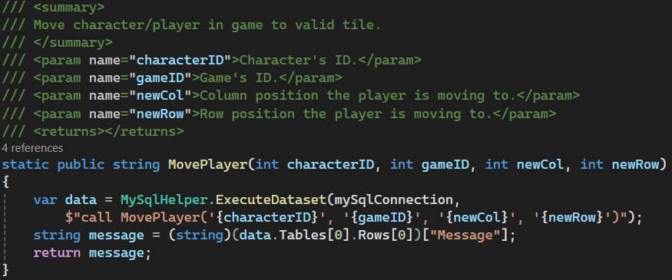

**Test Call**

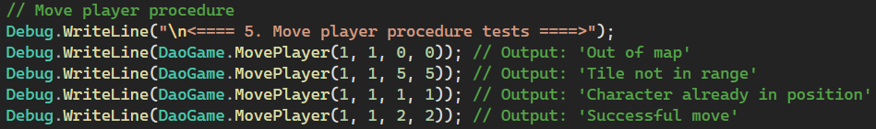

**Log Outputs**

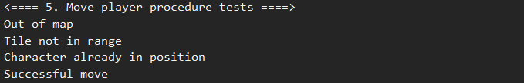

### GUI Implementation

There are currently two temporary movement methods to demonstrate the movement. One increases the column position by one, the other increases the row position by one.

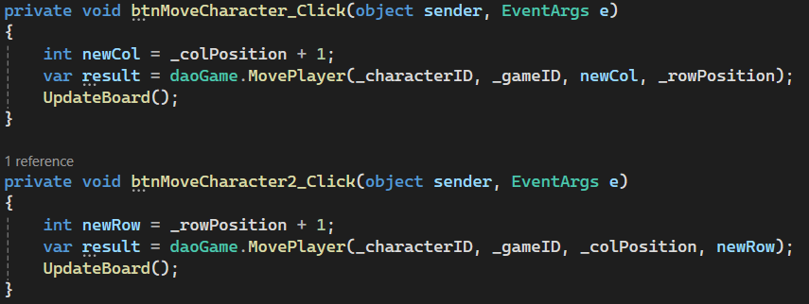

The player is at the starting tile of 1,1.

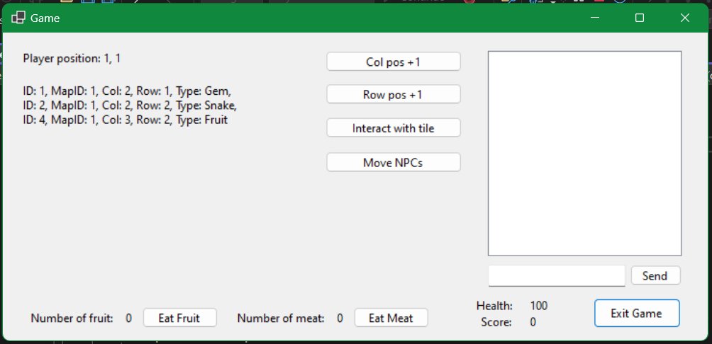

After pressing both movement buttons a few times, the player is now at 3, 2. Note that the map display has changed as more tiles are now in the view distance of 4 tiles.

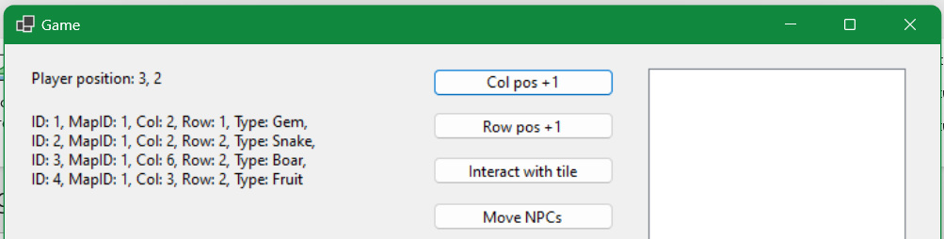

## Update Score Procedure

### MySQL Procedure

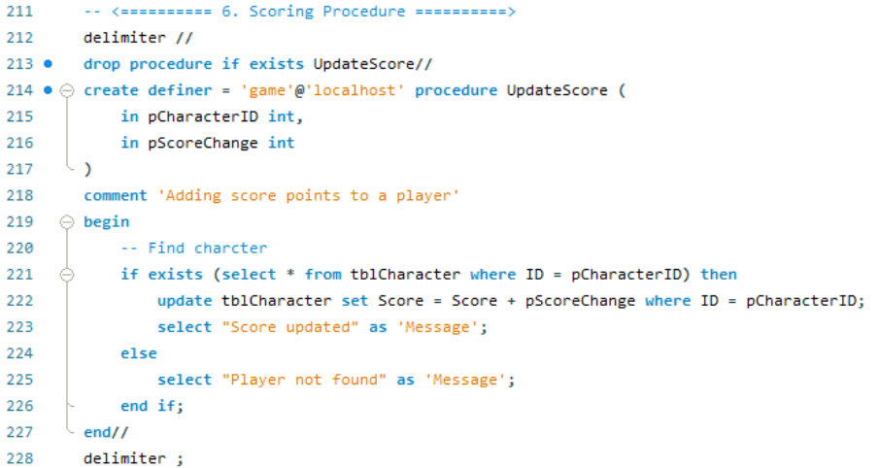

**Test Calls and Checks**

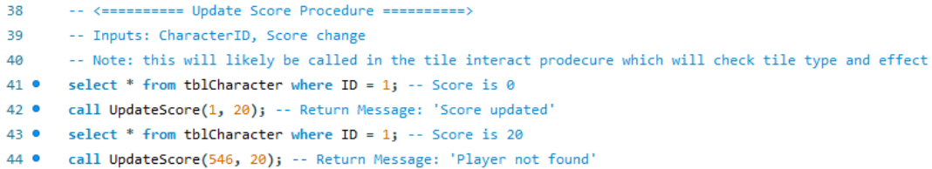

**Results**

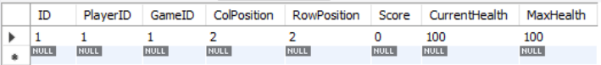

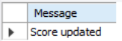Send score +20

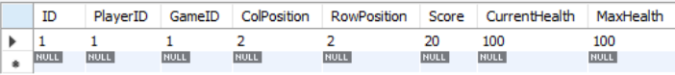

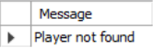 Invalid player ID

### C# Test

**DAO Method**

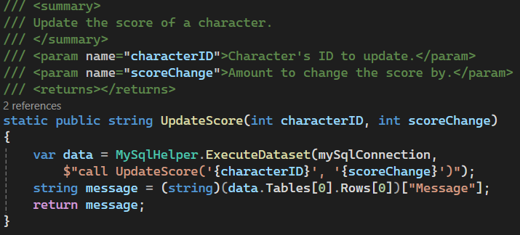

**Test Calls**

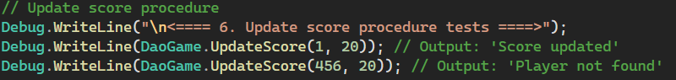

**Log Output**



### GUI Implementation

Please read the interact (pickup) procedure GUI implementation below as these are closely related with their workings and implementation.

## Interact (Pickup) Procedure

### MySQL Procedure

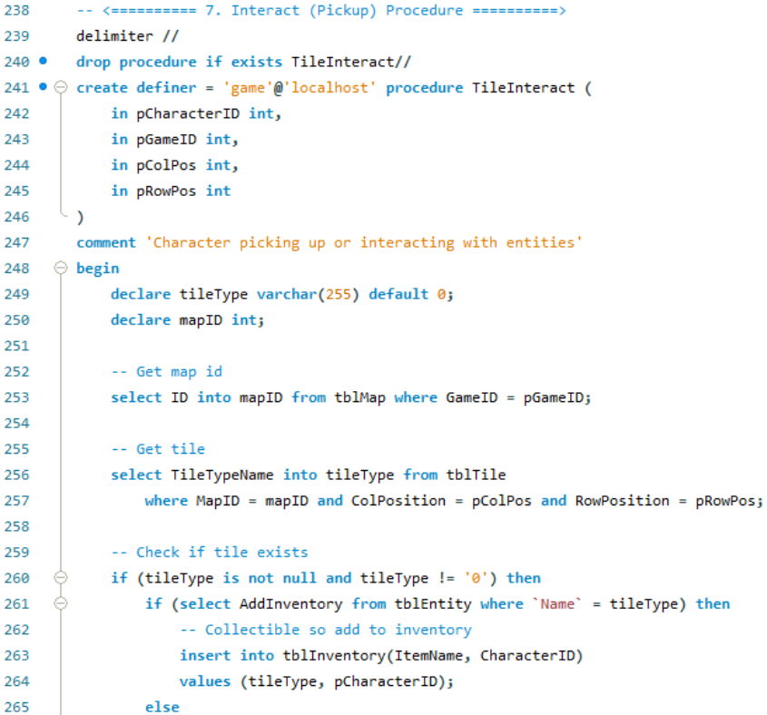

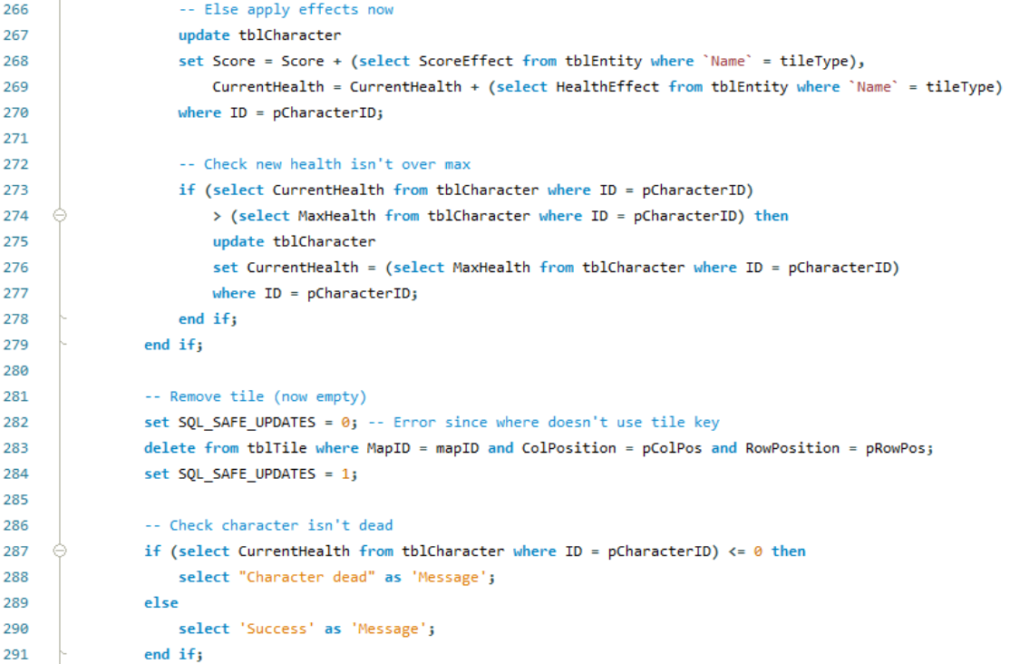



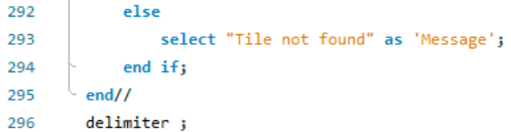

**Test Calls and Checks**

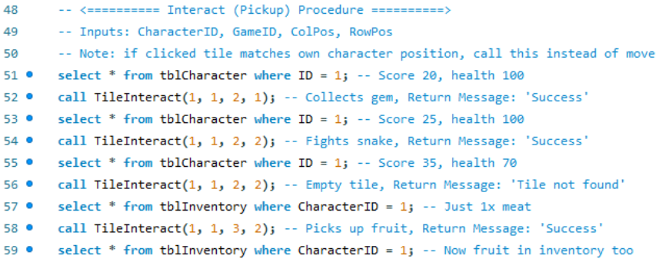

**Results**



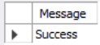 Collect gem, +5 score



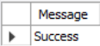 Fight snake, +10 score, -30 health



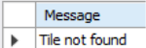 Test call invalid tile

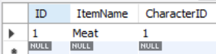 Inventory before

 Collect 1x fruit item

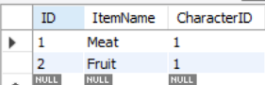 Fruit in inventory

### C# Test

**DAO Method**

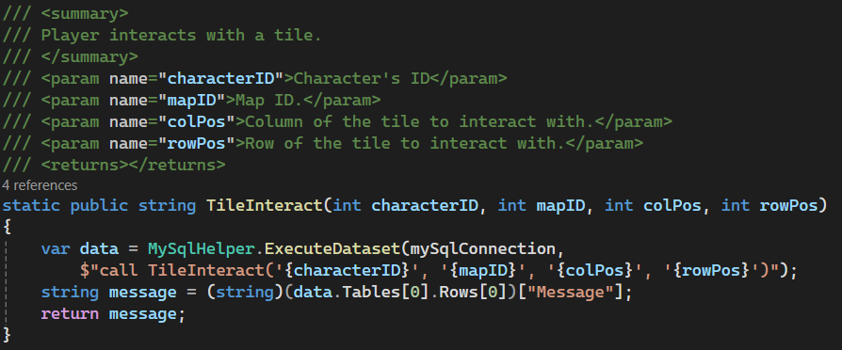

**Test Calls**

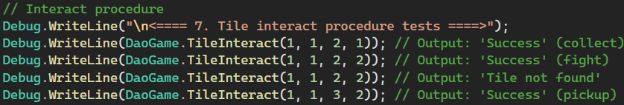

**Log Outputs**

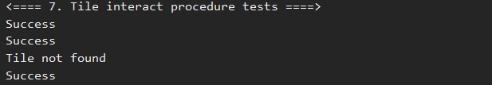

### GUI Implementation

Player is on 1,1 which contains a coin. Pressing the interact with tile button will run the interact script.

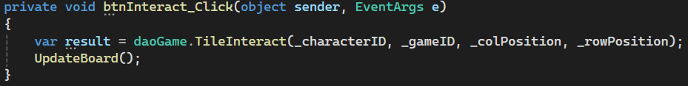

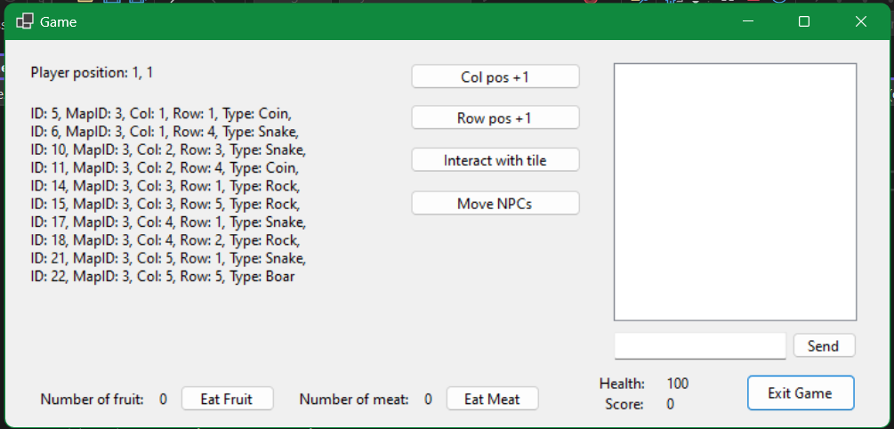

After interacting with the tile, the coin has been removed and the player’s score has increased from 0 to 1.

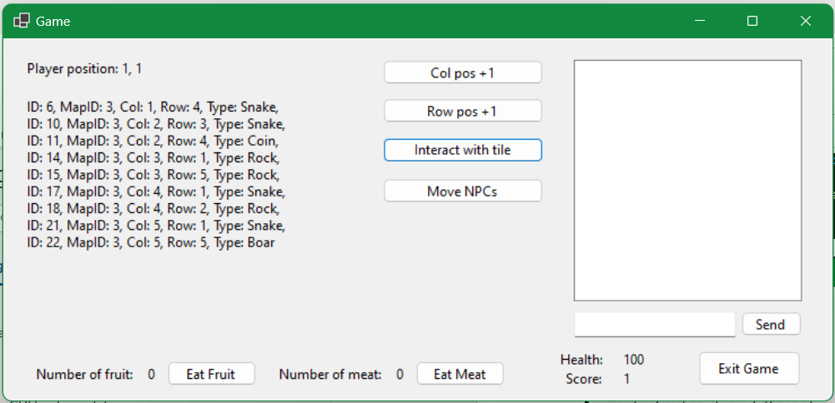

Now the player is at 1,6 over a snake.

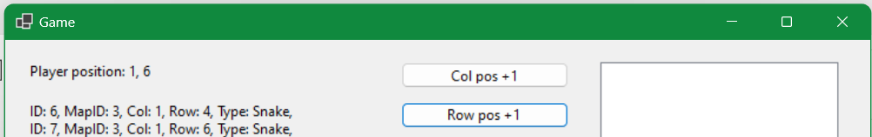

Interacting with the tile and fighting the snake will decrease the health (-30) and add score (+10).

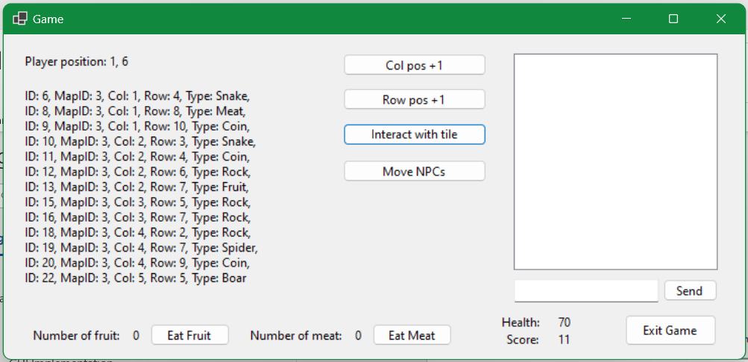

## NPC Movement Procedure

### MySQL Procedure

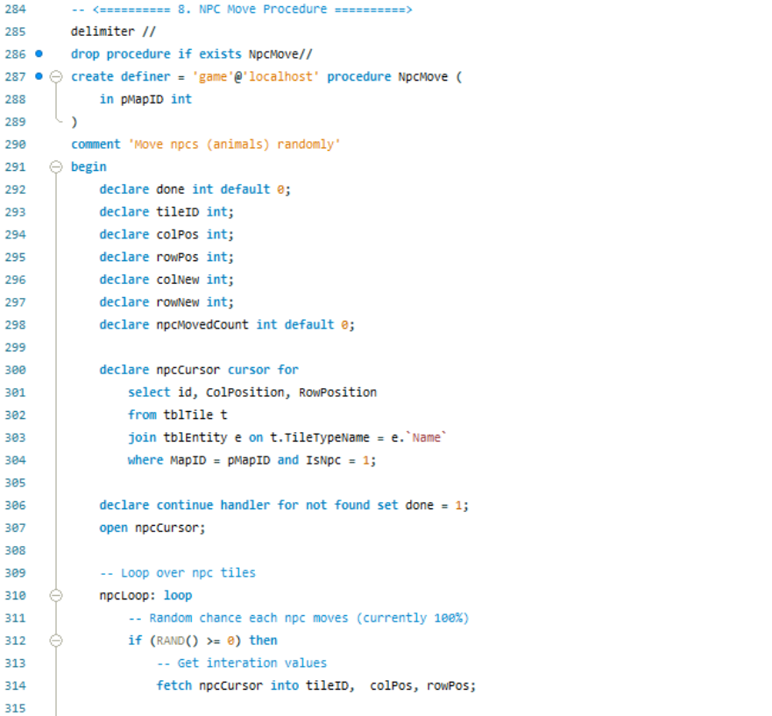



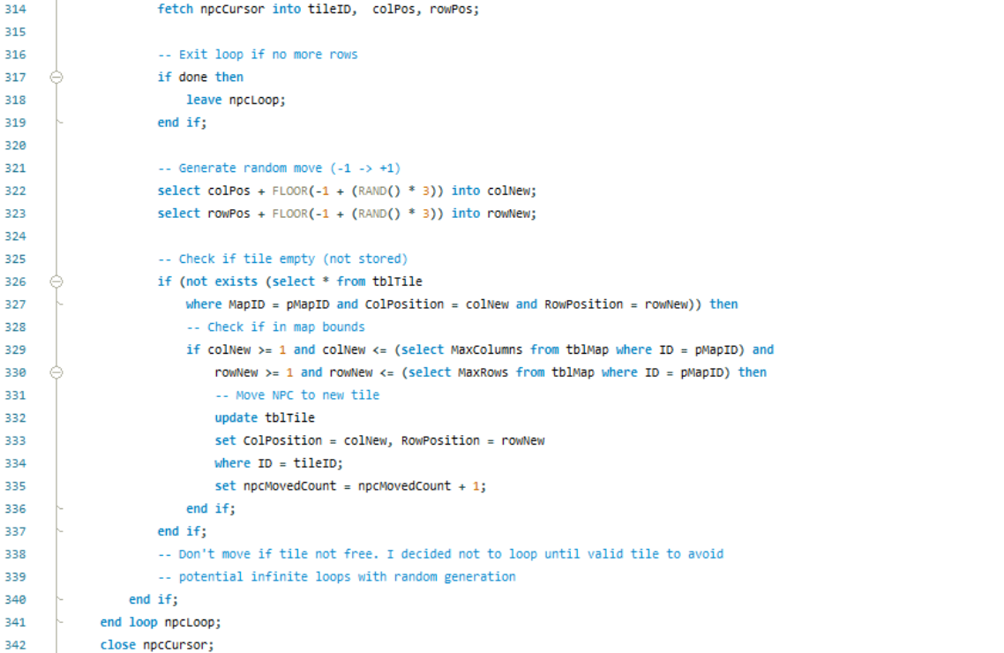

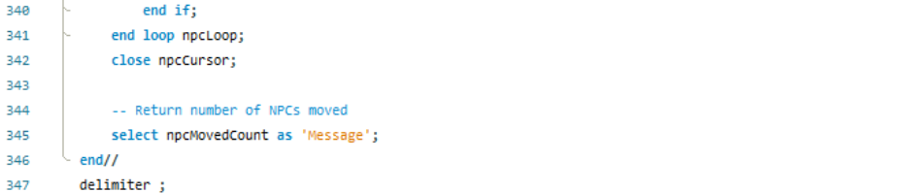

**Test Calls and Checks**

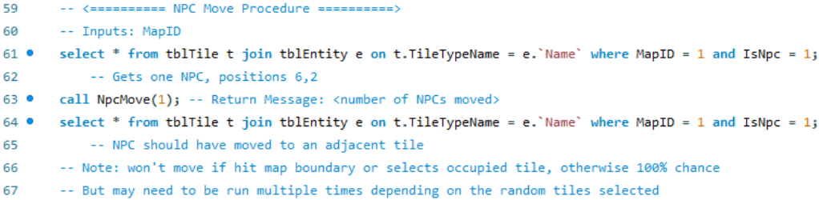

**Results**



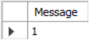 Boar moved from 6,2 -> 5,1



### C# Test

**DAO Method**

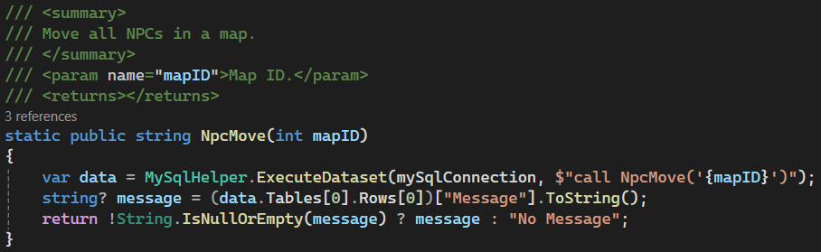

**Test Calls**

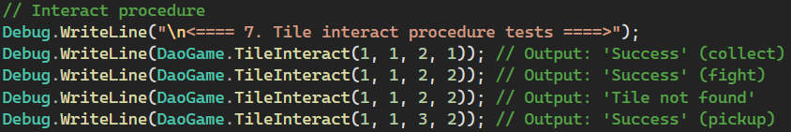

**Log Output**

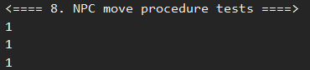

### GUI Implementation

Note how there is a snake at 1, 4 and 2, 3.

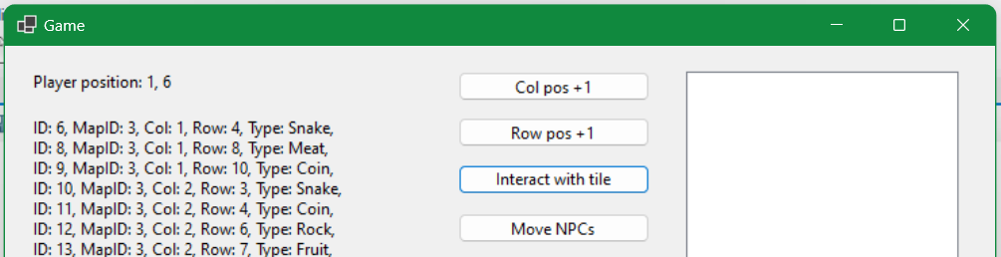

Pressing the move NPC button will run the move procedure and display a message box with the number of NPCs moved. Note, NPCs will not always move if the random new position is already a unique tile.

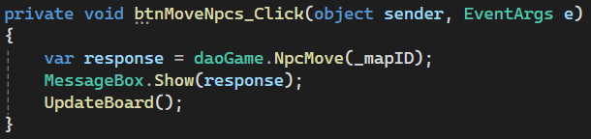

Note the snakes are now at 2, 3 and 5, 4.

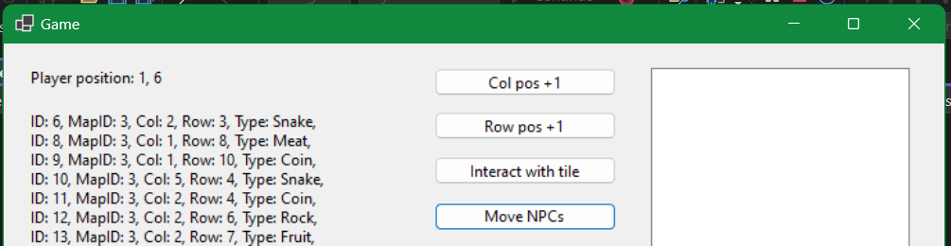 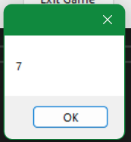

## Stop Game Procedure

### MySQL Procedure

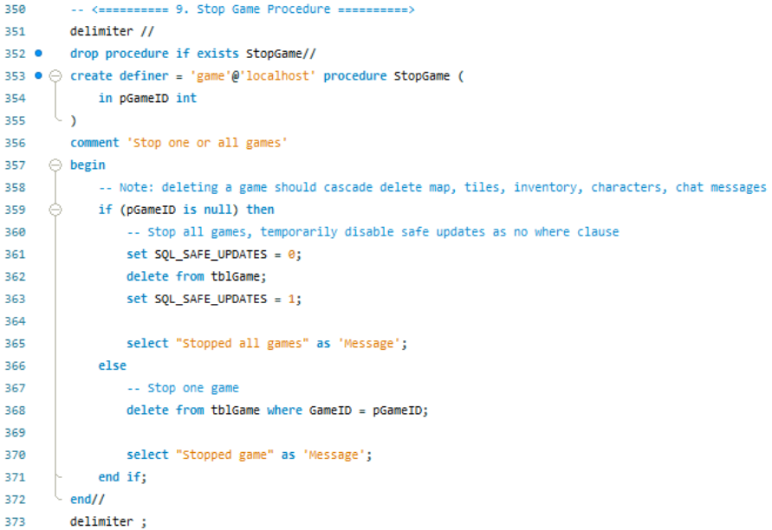

**Test Calls and Checks**

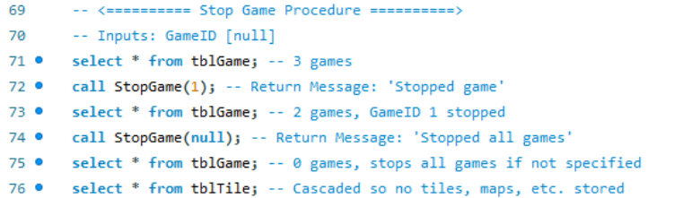

**Results**

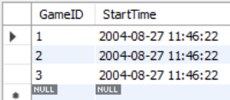 Starts with 3 games

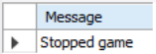 First call stops game 1

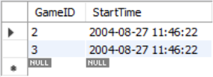 GameID 1 gone

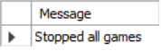 Second call stops all remaining games

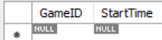 No games

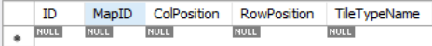 Cascade deletes tiles, etc.

### C# Test

**DAO Methods**

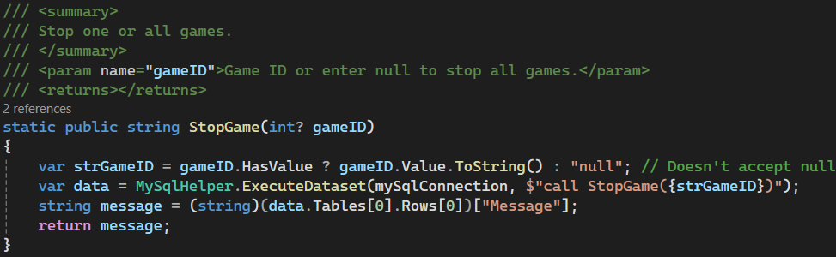

**Test Calls**

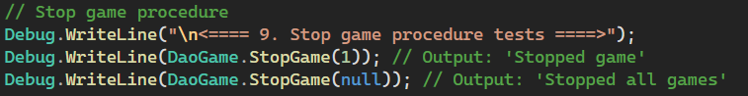

**Log Outputs**

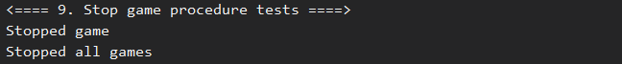

### GUI Implementation

From the lobby, clicking the admin button will load the admin screen. This screen shows the online players and games.

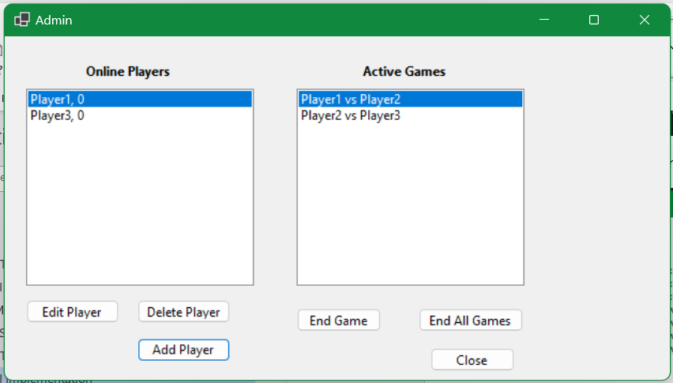

Selecting a game and clicking end game will end that game, cascade deleting all data from the database. Clicking end all games will end all games.

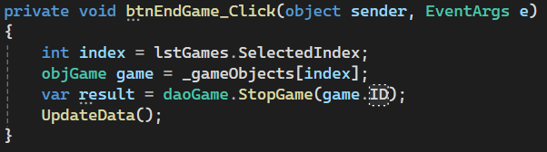

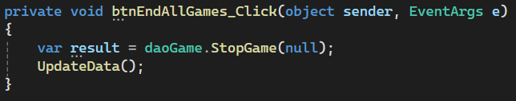

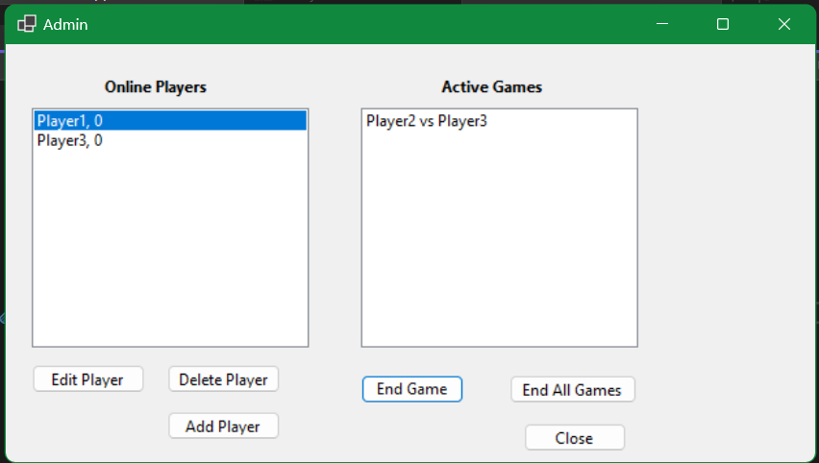

## New Player Procedure

### MySQL Procedure

This procedure uses the same MySQL procedure as the player register. Please refer to the register procedure section.

### C# Test

This procedure uses the same MySQL procedure as the player register. Please refer to the register procedure section.

### GUI Implementation

Player list before. Note 4 players.

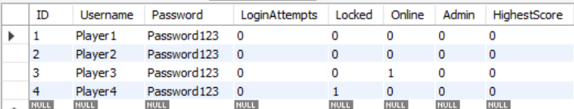

From the admin view, the user can press the add player button, which will create a new example user account. This will eventually have a form tied to it.

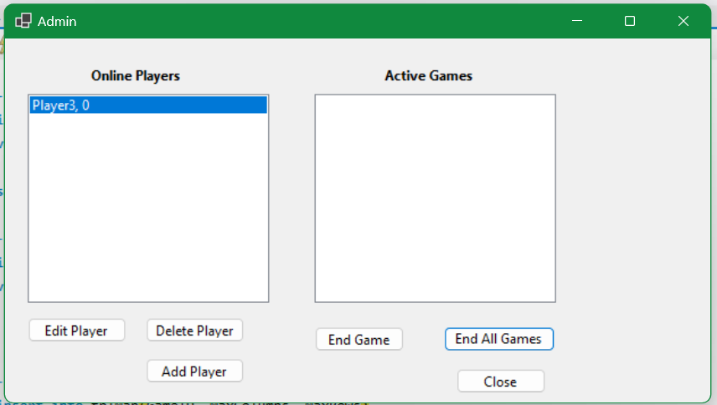

Clicking add player has added a new account (U: “MegaX”, P: “Password123”). A popup confirms that the account is created. Note however that while the player account has been created, it is not logged into, so it is offline and will not show up in the active player list.

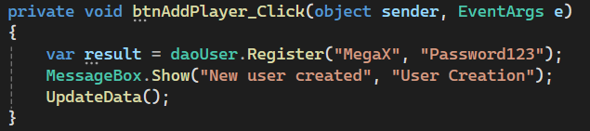 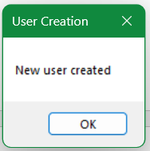

New account is in the database.

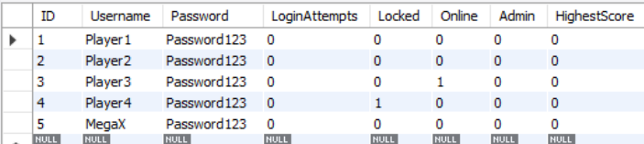

## Update Player Procedure

### MySQL Procedure

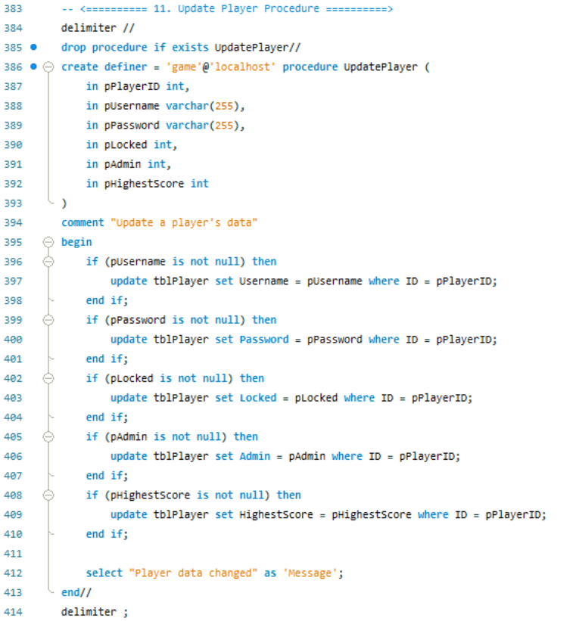

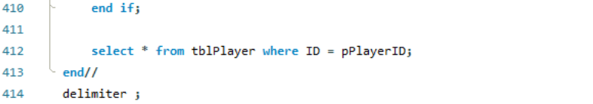

**Test Calls and Checks**

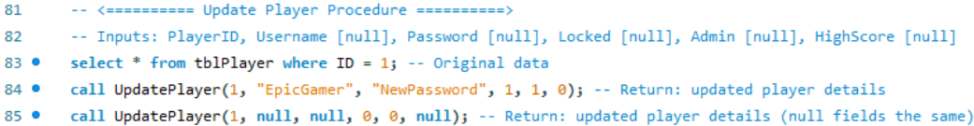

**Results**

 Before

 Full change

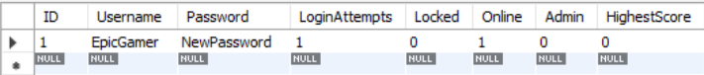 With nulls

### C# Test

**DAO Method**

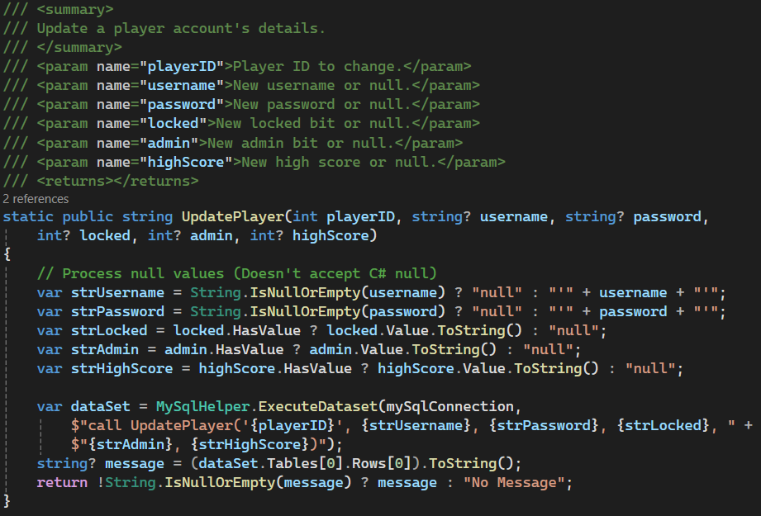

**Test Calls**



**Log Outputs**

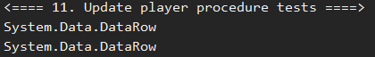

### GUI Implementation

When a user clicks the edit player button, player 1’s username will be updated. This is current set to always change player 1’s id as an example but will be integrated with an update details form in account management.

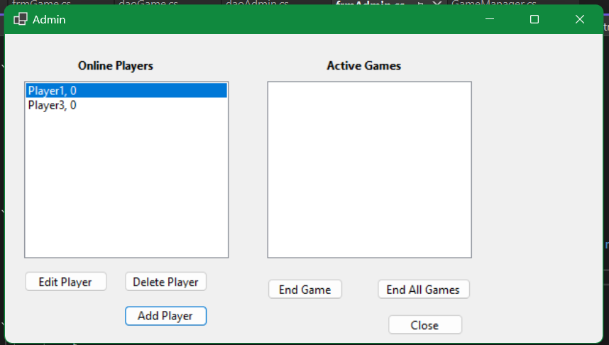

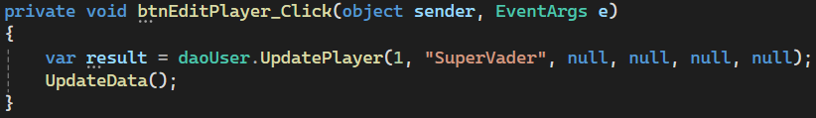

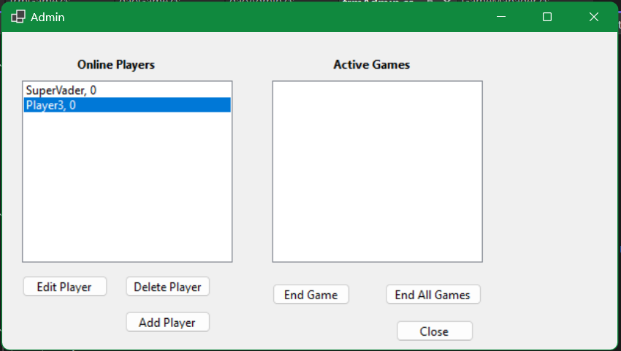

## Delete Player Procedure

### MySQL Procedure

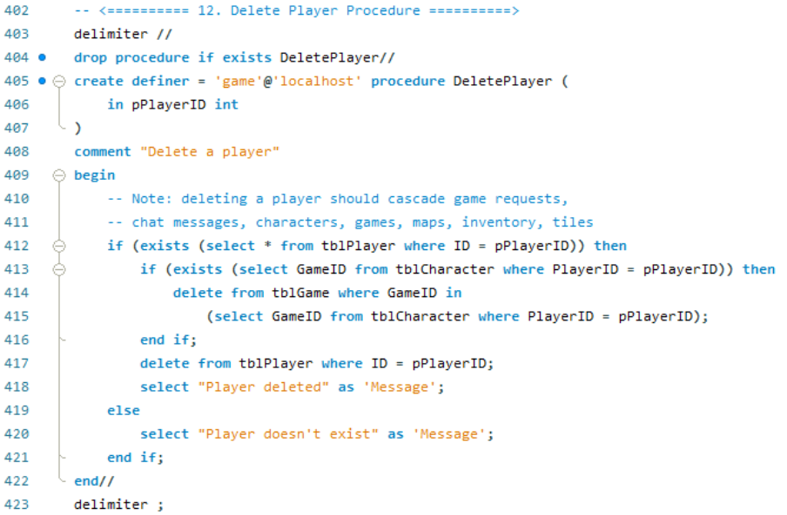

**Test Calls and Checks**

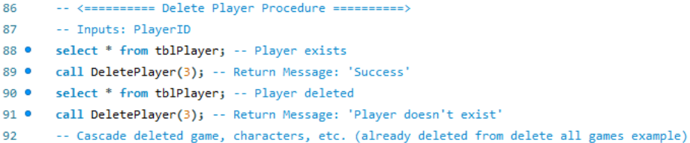

**Results**

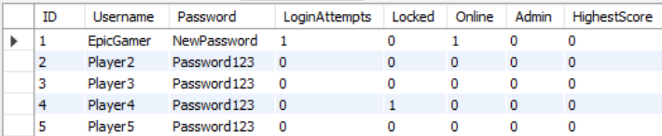 Before

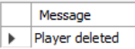 Delete Player 3

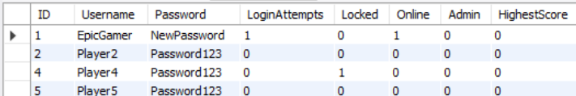 After

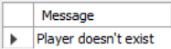 Deleting invalid player id

### C# Test

**DAO Methods**

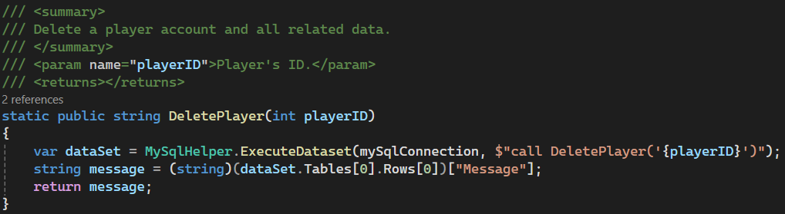

**Test Calls**

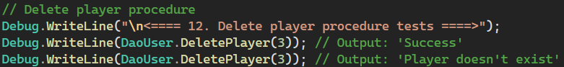

**Log Outputs**

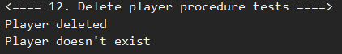

### GUI Implementation

By selecting an online player, and clicking delete player, the user can delete player accounts. This will cascade delete any characters, games, maps, tiles, inventories, etc.

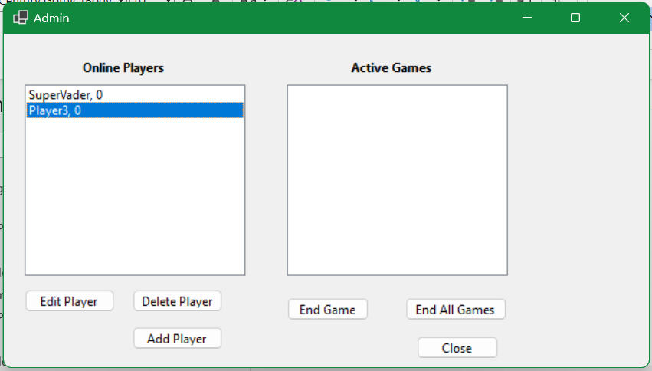

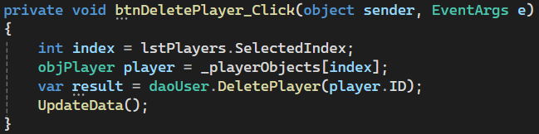

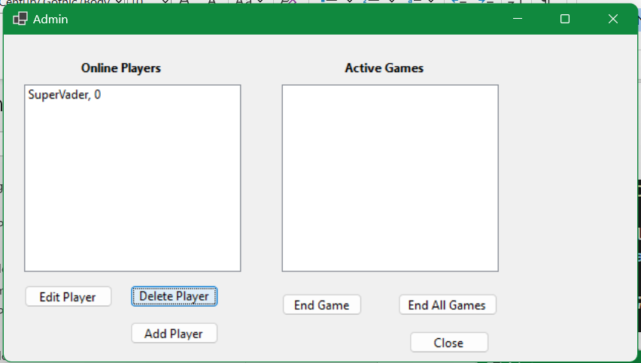

# Multiuser Concurrency (Milestone 3)

To be done later.

# References

**There are no sources in the current document.**